# Open Access to Knowledge and Information

Scholarly Literature and Digital Library Initiatives

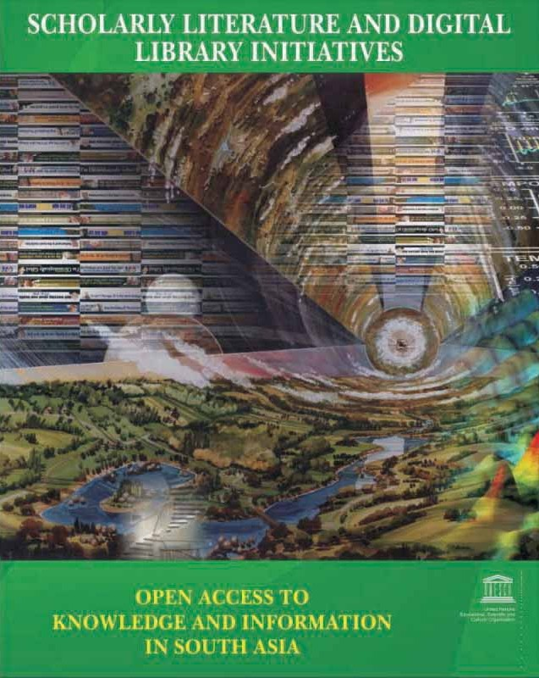

***UNESDOC***

*2008-04-08 11:33:04*

--------------------------------------------

Document partially illegible

***The South Asian Scenario***

United Nations EducatioUnanli,teSdciNenattiifoicnsand EducatioCnuallt,uSraclieOnrtgifaicniaznadtion

Cultural Organization



**Open Access to Knowledge and Information**

Scholarly Literature and Digital Library Initiatives The South Asian Scenario

Anup Kumar Das

Edited by Bimal Kanti Sen and Jocelyne Josiah



Open Access to Knowledge and Information : Scholarly Literature and Digital Library Initiatives - The South Asian Scenario

Anup Kumar Das

Edited by: Bimal Kanti Sen and Jocelyne Josiah

#### © UNESCO 2008

ISBN 978-81-89218-21-8

This publication may be reproduced in any media appropriately acknowledging UNESCO and the authors.

Design, Typesetting & Graphics: Nikhil Offset Printers, New Delhi

#### Published by:

The United Nations Educational Scientific & Cultural Organization (UNESCO) UNESCO House

B-5/29, Safdarjung Enclave New Delhi 110029

India

Phone: +91-11-26713000 Fax: +91-11-26713001/2

Email: [newdelhi@unesco.org](mailto:newdelhi@unesco.org)

#### Disclaimer

The authors are responsible for the choice and the presentation of the facts contained in this publication and for the opinions expressed therein, which are not necessarily those of UNESCO and do not commit the Organization. The designations employed and the presentation of materials throughout the publication do not imply the expression of any opinion whatsoever on the part of UNESCO concerning the legal status of any county, territory, city or area or of its frontiers or boundaries.

## FOREWORD



Universal access to information and knowledge lies UNESCO's overall mandate to promote the free flow of information by word and by image and thus to place information and knowledge at the doorsteps of communities. UNESCO strives to forge an enabling environment to facilitate and open up avenues for universal access to information and knowledge.

Open Access to information and knowledge is an innovative mode of scholarly communication within the digital environment aimed at achievement of universal access to information and knowledge. While Open Access helps digital inclusion of citizens in developing countries by bringing within easy reach full-text contents of scholarly works, documentary heritage collections and development-related literature, the Digital Library remains a knowledge repository of such citizens, indigenous people, communities and institutions. Open Access to knowledge is a model adopted by many international and intergovernmental fora, such as the World Summit on the information Society (WSIS), for disseminating full-text contents to online communities.

The South Asia sub-region is now in the forefront of the Open Access movement within developing countries in the world, with India being the most prominent partner in terms of its successful Open Access and Digital Library initiatives. Institutional and policy frameworks in India also facilitate innovative solutions for increasing international visibility and accessibility of scholarly literature and documentary heritage in this country.

This publication has its genesis in the recommendations and proceedings of UNESCO-supported international conferences and workshops including the 4th International Conference of Asian Digital Libraries (ICADL2001, Bangalore); the International Conferences on Digital Libraries (ICDL2004 & ICDL2006, New Delhi); and the International Workshop on Greenstone Digital Library software (2006, Kozhikode), where many information professionals of this sub-region demonstrated their Digital Library and Open Access Initiatives. It discusses successful activities in the South Asia sub- region bringing closer to the worldwide audience, the subject of access to scholarly literature and documentary heritage. This may thus be considered an authoritative source-book on Open Access Development in this sub-region.



**Jocelyne Josiah**

**Adviser in communication and information for Asia UNESCO**

**New Delhi**



|  |  |
| --- | --- |
|  | **CONTENTS** |
| **Introduction** | **1** |
| **Digital Library Initiatives** | **7** |
| **Open Courseware Initiatives** | **43** |
| **Open Access Journals** | **56** |
| **Metadata Harvesting Services** | **69** |
| **National-Level Open Access Repositories** | **83** |
| **Institutional Repositories** | **96** |
| **Conclusion** | **128** |
| **References** | **129** |
| **Annexure** | **130** |
| **Book Chapters Index** | **133** |
| **Other Useful Open Access Resources and Knowledge Portals** | **136** |



**INTRODUCTION**

In the information society, free flow of information is a fundamental principle for bridging the knowledge gaps between privileged and under-privileged communities. Social inclusion and economic empowerment are also achieved in a society where citizens have universal access to information and knowledge, ranging from public information to specialized or customized information related to ones' profession, vocation or culture. Open access to information and knowledge is a key contributor in provisioning universal access to information and knowledge. Thus, the open access movement is gaining momentum in developed countries which already have necessary information infrastructure.

The emerging economies amongst the developing countries are not far behind in building up necessary information infrastructure, essential for sustainable economic development. These emerging countries, however, have limitations in terms of bridging the digital divide within their societies, due to the co-existence of marginalized and privileged communities. With the availability of advanced information and communication technologies (ICTs) and by building up necessary information infrastructure in South Asia, particularly in India, this sub-region becomes an active contributor to global open access literature, a contribution, almost proportionate to its flow of scholarly literature through subscription-based channels. For several thousand years, South Asian literature has been developing, explicit with knowledge of the time.

Traditional knowledge, presently available amongst indigenous people in folklore or other forms, is now being explored and documented. The digitization of century-old publications and rare documents is being carried out in different institutions across this sub-region to preserve them and make them accessible through networks of digital archives. E-content is are being produced by members of different communities, facilitated by certain development organizations, including the apex higher education agencies (viz., University Grants Commission, India; Higher Education Council, Pakistan); apex research councils (e.g., Council of Scientific and Industrial Research, India; Indian Council of Medical Research, India), and grassroots-level civil society organizations (e.g., OneWorld South Asia). India has spearheaded the open access movement in developing countries since the last decade upscaling print-based scholarly journals into open access electronic journals, and establishing a number of open access repositories, both at national and institutional levels embracing free and open source software (FOSS). Establishment of open courseware and cross-archive search services are new fronts of open access initiatives.

1

Indian information professionals are experimenting with open source software in the establishment of institutional repository (IR) systems in local libraries, using Greenstone, DSpace or EPrints software. Once an IR is successfully implemented in the local library setup, it is then upscaled to institution-wide application through campus networks or intranet. Similarly, it may open up to wider audiences once the authorities of the institution are convinced. With the availability of dedicated information infrastructure combined with 24X7 broadband connectivity and the national educational grid, some institutions and universities created institutional repositories for wide dissemination of their own scholarly literature. Some open access repositories are specially created to diffuse intellectual outputs of the country in the form of electronic theses and dissertations: Vidyanidhi, ETD@IISc in India and the Pakistan Research Repository are examples. Other national level open access repositories provide all kinds of scholarly materials such as research papers, conference papers, technical reports, presentations, photographs, news clippings, and e- theses on particular disciplines. The OpenMED@NIC and Librarians' Digital Library are also examples of this kind.



In the wake of the open access movement, some policy frameworks have already been established by member communities to foster inclusive, plural and development-oriented knowledge societies. A number of open access declarations/ statements were made during the past decade, where the world's leading research institutions agreed on the open access mandates. An indicative list of major open access statements or declarations is given in Table 1. The United Nations-backed World Summit on the Information Society (WSIS) strongly supported open access to information and knowledge. This confirms that member countries of the United Nations will take appropriate strategic decisions to bring scholarly literature, produced from public funded research initiatives or state-supported researchers, under the umbrella of open access. Annexure illustrates the WSIS Declaration of Principles and Plan of Action on access to information and knowledge. The plan of action relevant to long-term preservation of cultural contents, creation of local content and open access to scholarly literature is also shown in Annexure.

2

##### Table 1: Major Open Access Statements / Declarations



•ARIIC Open Access Statement (Australian Research Information Infrastructure Committee) [[www.caul.edu.au/scholcomm/OpenAccessARIICstatement.doc]](http://www.caul.edu.au/scholcomm/OpenAccessARIICstatement.doc)

•Berlin Declaration on Open Access to Knowledge in the Sciences and Humanities [[http://oa.mpg.de/openaccess-berlin/berlindeclaration.html]](http://oa.mpg.de/openaccess-berlin/berlindeclaration.html)

•Bethesda Statement on Open Access [[www.earlham.edu/~peters/fos/bethesda.htm]](http://www.earlham.edu/~peters/fos/bethesda.htm)

•Budapest Open Access Initiative Statement [[www.soros.org/openaccess/]](http://www.soros.org/openaccess)

•ERCIM Statement on Open Access (European Research Consortium for Informatics and Mathematics) [[www.ercim.org/publication/Ercim_News/enw64/ercim-oa.html]](http://www.ercim.org/publication/Ercim_News/enw64/ercim-oa.html)

•IFLA Statement on Open Access to Scholarly Literature and Research Documentation (International Federation of Library Associations and Institutions) [[www.ifla.org/V/cdoc/open-access04.html]](http://www.ifla.org/V/cdoc/open-access04.html)

•NKC Statements on Open Access (National Knowledge Commission, India) [[http://knowledgecommission.gov.in/downloads/documents/wg_lib.pdf &](http://www.ifla.org/V/cdoc/open-access04.html) [http://knowledgecommission.gov.in/downloads/documents/wg_open_course.pdf]](http://knowledgecommission.gov.in/downloads/documents/wg_lib.pdf%26knowledgecommission.gov.in/downloads/documents/wg_open_course.pdf)

•OECD Declaration on Access to Research Data from Public Funding (Organisation for Economic Co-operation and Development) [[www.oecd.or](http://www.oecd.org/document/0%2C2340)g/document/0,2340,en_2649_34487_25998799_1_1_1_1,00.html]

•Washington DC Principles for Free Access to Science: A Statement from Not-for- Profit Publishers [[www.dcprinciples.org/statement.htm]](http://www.dcprinciples.org/statement.htm)

•Wellcome Trust Position Statement in support of open and unrestricted access to published research [[www.wellcome.ac.uk/doc_WTD002766.html]](http://www.wellcome.ac.uk/doc_WTD002766.html)

•WSIS Declaration of Principles and Plan of Action (World Summit on the Information Society) [[www.itu.int/wsis/docs/geneva/official/dop.html &](http://www.wellcome.ac.uk/doc_WTD002766.html) [http://www.itu.int/wsis/docs/geneva/official/poa.html]](http://www.itu.int/wsis/docs/geneva/official/dop.html%26www.itu.int/wsis/docs/geneva/official/poa.html)

The National Knowledge Commission of India (NKC), constituted on 13th June 2005, is a high- level advisory body to the Prime Minister of India, with a mandate to guide policy and direct reforms. NKC's overarching aim is to transform India into a vibrant knowledge-based society. The NKC's *Working Group on Open Access and Open Educational Resources* and *Working Group on Libraries* have strongly recommended open access to public-funded research literature and supported establishment of open courseware repositories for countrywide dissemination of quality courseware to many cross-sections of people. If implemented, these recommendations will have far-reaching implications in the knowledge creation and dissemination cycle. The scholarly literature and lifelong learning materials produced by state-sponsored institutions would then be made accessible through open access channels such as national and institutional repositories. This way the NKC's recommendation on peer-reviewed research papers resulting from public-funded research would be validated by subject experts when making these resources available through open access channels. NKC also recommended creation of national knowledge portals for basic needs/ key sectors such as water, energy, environment, education, food, health, agriculture,

3

employment and citizen rights. Already national portals on water (India Water Portal, [www.indiawaterportal.org),](http://www.indiawaterportal.org/) energy (India Energy Portal, [www.indiaenergyportal.org)](http://www.indiaenergyportal.org/) and education (Sakshat, [www.sakshat.ac.in)](http://www.sakshat.ac.in/) have been established that provide open access to information, knowledge and learning resources on the relevant areas.



**Table 2: NKC Working Group on Open Access and Open Educational Resources - Recommendations**

***Encourage Open Access***

“Open access material stimulates research and helps students, teachers and researchers across the world. Therefore at a policy level, all research articles published by Indian authors receiving substantial government or public funding must be made available under Open Access and should be archived in the standard OA format at least on his/her website. As a next step, a national academic OA portal should be developed. The government should allocate resources to increase the current digitization efforts of books and periodicals which are outside copyright protection. Separate funding should be allocated to develop a new high quality OCR software package so that new and old fonts in many different Indian languages can be converted into ISCI/ASCI code and OA portals and servers could be upgraded regularly. Appropriate financial resources should be earmarked for these endeavours. This will also facilitate machine translation of these valuable resources.”

*Source: Report of the Working Group on Open Access and Open Educational Resources*

[*http://knowledgecommission.gov.in/downloads/documents/wg_open_course.pdf*](http://knowledgecommission.gov.in/downloads/documents/wg_open_course.pdf)

##### Table 3: NKC Working Group on Libraries Recommendations

***Digitization and Open Access***

To enable equitable and universal access to knowledge resources, it is important to create more digital resources which can be shared. The concept of an “information commons” i.e. “resources shared by a community of producers and consumers in an open access environment” needs to be promoted. New resources should be openly accessible and historical documents, too, should be digitized and made available.

•This Working Group strongly recommends that peer-reviewed published research papers resulting from publicly funded research in India must be made available through open access channels, subject to copyright regulations. The group also recommends use of open standards and free and open source software.

•All pre-independence periodicals and newspapers in all Indian languages and in English must be digitized for access and preservation.

To help preserve digital resources, optimize their use and avoid duplication of effort:

•State-level archives for preservation of digitized materials must be set up.

•Every State should establish a registry and archives of knowledge-based digital resources, and make it accessible.

*Source: Report of the Working Group on Libraries* [*http://knowledgecommission.gov.in/downloads/documents/wg_lib.pdf*](http://knowledgecommission.gov.in/downloads/documents/wg_lib.pdf)

4

In 2005, the University Grants Commission of India (UGC) drafted a national policy framework entitled “UGC (Submission of Metadata and Full-text of Doctoral Theses in Electronic Format) Regulations, 2005”. This Regulation proposed two sets of planned actions, such as:



•Creation of Indian National Theses Database (INTED)

•Submission of PhD Theses in Electronic Form

This set of regulations is still under consideration. They propose to formulate a roadmap to achieve widest dissemination of results of doctoral research conducted in Indian universities and bibliographic control of theses and dissertations of research degrees. So far, a few UGC-supported universities have established open access repositories for scholarly literature produced in the respective universities. Initially the universities were reluctant to change their status quo, as the contents of scholarly literature including the PhD theses will be a matter of critical analysis by the national and international peers, if the universities establish open access repositories. Now, universities will be motivated to produce qualitative doctoral theses and will maintain certain international standards. The UGC also supports development of infostructure in Indian universities through various planned schemes. The proposed national education grid will also enrich modern ICT infrastructure in Indian universities. The Indian universities then will have necessary infrastructure to host a number of web-based information services. Hosting an ETD repository and providing online interface to INTED will not be a problem in most of the universities. Indian universities should now take a proactive role in the implementation of these regulations at the earliest, ensure qualitative research and make the results of doctoral research widely available. The UGC should also clear all bottlenecks to implement INTED and decentralized ETD repositories across the country.

Similarly, the Higher Education Commission (HEC) of Pakistan, a counterpart of India's UGC, is now supporting open access to public-funded scholarly literature, particularly theses and dissertations. HEC has established the Pakistan Research Repository to promote international visibility of research originating from institutes of higher education in Pakistan. This repository has already made the full-text of over 1600 doctoral theses available in high-quality digitized format.

On the other hand, development practitioners working in civil society organizations or development agencies are now in the forefront of e-content creation and facilitating e-content generation at the grassroots level. Some of the major challenges faced by them are long-term preservation of e-content, and establishing an efficient storage and retrieval system to render these resources open access in networked environments. Free and open source software for digital archiving such as Greenstone, DSpace, EPrints and GENISIS, are very efficient in handling these issues.

In South Asia, particularly in India, large volumes of cultural heritage resources (documentary) are on the verge of extinction due to lack of preservation, non-availability, rarity and natural decay. The knowledge and wisdom lost from these cultural heritage documentary resources can cause a severe

5

vacuum in the intellectual wealth of humanity, if we cannot preserve them at this critical juncture. With the emergence of successful digital library projects in more developed countries, the public institutions in this region opted for long-term preservation of this wealth of knowledge through digitization projects and digital library initiatives. Diverse multi-cultural and multilingual contents are now being documented, preserved and made available through the internationally acclaimed digital library initiatives such as Digital Library of India (DLI), Traditional Knowledge Digital Library (TKDL), Kalasampada Digital Library-Resource for Indian Cultural Heritage (DL-RICH), Muktabodha Digital Library, Archives of Indian Labours, and United Nations Digital Library in Islamabad, and AHKRC Digital Library.



This book therefore strives to illustrate South Asian initiatives on open access to information and knowledge. Some of the common open access channels found in this sub-region are digital libraries, open access journals, institutional repositories, national-level repositories, open courseware, metadata harvesting services, etc. Most of the open access initiatives are supported by government bodies or public institutions, followed by non-profit making organizations.

6



**DIGITAL LIBRARY INITIATIVES**

7

### AHKRC Digital Library

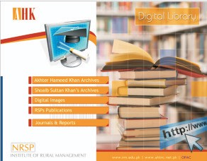

Type of Initiative: Digital Library

Principal Implementing Agency: Akhter Hameed Khan Resource Center (AHKRC), Islamabad, Pakistan

Supporting Agencies: National Rural Support Programme (NRSP), Islamabad; NRSP Institute of Rural Management, Islamabad, Pakistan

Software Used: Greenstone Digital Library Software

Web Address [1: http://www.lisolutions.org/gsdl/cgi-bin/library.exe](http://www.lisolutions.org/gsdl/cgi-bin/library.exe) Web Address [2: http://210.56.25.21/gsdl/cgi-bin/library.exe](http://210.56.25.21/gsdl/cgi-bin/library.exe)

##### Brief Description:

AHKRC Digital Library is an open access digital archive, named after Dr. Akhter Hameed Khan, an outstanding development activist and social scientist from Pakistan. This digital archive provides full-text access to some important works of Akhter Hameed Khan and Shoaib Sultan Khan, publications of National Rural Support Programme (NRSP) and digital images of the activities of NRSP/AHKRC. This repository also provides access to some selected journals and reports to the registered users.

8

### Archives of Indian Labour: Integrated Labour History Research Programme

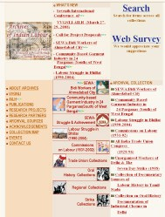

Type of Initiative: Digital Library

Principal Implementing Agency: V.V. Giri National Labour Institute, Noida

Participating Institutions: Association of Indian Labour Historians, Delhi; N. M. Joshi Centre for Labour Research and Education; Workers' Education Trust, Chennai; Roja Muthiah Research Library, Chennai; SARAI- A New Media Initiative, Center for Study of Developing Societies, New Delhi

Supporting Agency: Ministry of Labour, Government of India Software Used: Greenstone Digital Library Software

Web Address: <http://www.indialabourarchives.org/>

9

##### Brief Description:

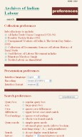

The Archives of Indian Labour (AIL) is a collaborative project of V.V. Giri National Labour Institute and the Association of Indian Labour Historians. AIL aims at preserving and making accessible archival documents on the working class of India to the people. Inaugurated on International Labour Day, 1st May 2002, this project is dedicated to the proud heritage of the Indian working class. It is a part of the Integrated Labour History Research Programme, which focuses on integrating and initiating research on labour history and is perhaps the first of its kind in the country. This portal is a gateway to the rich primary source materials relating to the labour history of south Asian region. AIL integrates historical and contemporary records on the Indian labour movement, industrial relations, trade unions, commission reports, and others, generated by the state and the business enterprises. Other materials such as personal narratives, video and audio materials related to labour have also been preserved in the Archives. AIL consists of several sets of archival collections such as All India Trade Union Congress (1928-96), Bharatiya Mazdoor Sangh, Bombay Textile Strike (1982), Documentary Sources of Labour History in Tamil Nadu, Oral History Documentation of Industrial Closure in Delhi, Second National Commission on Labour (2002), Commissions on Labour (1931-2002), Community-Based Garment Industry in 24 Parganas (South) of West Bengal, Labour Struggle in Bhilai (1990-2004), Oral History of the Labour Movement in India, SEWA: Bidi Workers of Ahmedabad City, Textile Labour in Ahmedabad, and Un-organised Workers of Delhi and The Seven Day Strike (1988). Its special collections are on key events in India's labour history. AIL has four thematic collections, i.e. Trade Union Collections, Oral History Collections, Regional Collections, and Strike Collections. AIL uses Greenstone digital library software for content organization and dissemination. When a search query is entered in this portal, the search engine retrieves documents that match some or all of the words from the entire books, or chapters, or section titles. Then it displays the search result with a link to each document. AIL also has a collection map that helps in navigating different collections. The collection preferences, search preferences and presentation preferences also help users to access the archived documents conveniently.

Figure 1: Customization of AIL through Collection, Presentation and Search Preferences

10

### Child Trafficking Digital Library

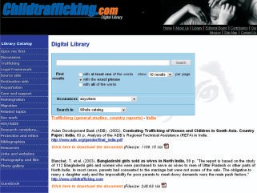

11

Type of Initiative: Digital Library



Principal Implementing Institution: Terre des Hommes in Nepal

Participating Institutions: UNICEF; and the International Labour Organisation (ILO) Supporting Agency: The Swiss Foundation of Terre des Hommes (Tdh), Switzerland; International Federation Terre des Hommes (IFTDH), Switzerland

Web Address: [http://www.ChildTrafficking.com](http://www.ChildTrafficking.com/)

Allied Project: International Campaign against Child Trafficking

[http://www.stopchildtrafficking.org](http://www.stopchildtrafficking.org/)

##### Brief Description:

Child trafficking is a menace in developing countries, particularly in South Asian sub-region. Child trafficking is linked to poverty, illiteracy, lack of livelihood options and limited access to social securities. Although some developing countries have legal frameworks to address the problem of child trafficking, comprehensive implementation strategies are also needed in the society. The movement of trafficked children from less developed countries to developed countries can also be checked, if the developed countries take appropriate action. International and national agencies, local bodies and civil society organizations join hands to work together with marginalized communities at the grassroots level to combat this intense problem, particularly where traffickers are more organized. In October 2001, Terre des Hommes launched an international campaign, called 'Stop Child Trafficking' which gained momentum in this region. The campaign is run together with local partners by regional coordinators and delegates in 33 countries of the six regions, i.e. Europe, Southeast Asia, South Asia, Southern Africa, South America and Western Africa. Over the last two decades, anti-trafficking organizations and individuals all over the world have clarified issues, conducted research, developed strategies and carried out interventions.

The Child Trafficking Digital Library is a global internet platform for sharing the accumulated knowledge, skills and experience on child trafficking. This repository provides access to archived documentary resources in the areas of trafficking, legal framework, source side, destination side, repatriation, care and support, reintegration, migration, related topics, sex work, HIV/AIDS, research considerations, protection and ethics. Apart from publications, there are documents and reports on child trafficking. This repository is referral to related resources such as discussions, bibliographies, website links, and photo galleries. This platform gets updated on a regular basis.

12

### CSIR Explorations

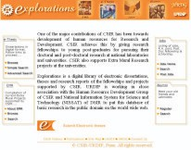

Type of Initiative: Digital Library

Principal Implementing Agency: CSIR Unit for Research and Development of Information Products (URDIP) at Pune

Supporting Agency: Council of Scientific and Industrial Research (CSIR), Government of India Web Address: <http://csirexplorations.com/>

Allied Projects:

•PATESTATE: A Database of CSIR Patents [http://www.patestate.com](http://www.patestate.com/)

•DSpace at National Chemical Laboratory [http://dspace.ncl.res.in/dspace/](http://dspace.ncl.res.in/dspace)

•Comprehensive Traditional Knowledge Digital Documentation and Library <http://www.csir.res.in/External/Heads/aboutcsir/network_projects.htm>

•National Science Digital Library <http://www.csir.res.in/External/Heads/aboutcsir/network_projects.htm>

##### Brief Description:

The CSIR *Explorations* is a digital library of electronic dissertations, theses and research reports of the fellowships and projects supported by CSIR. Presently, Explorations consists of three bibliographic databases, namely, E-Thesis, EMR (Extramural Research) and CSIR Publications. E-Thesis database is an authoritative source for information about doctoral theses and dissertations, submitted in Indian universities by researchers who availed CSIR Junior Research Fellowships (JRF) or Senior Research Fellowships (SRF). CSIR fellows carry out their research work in over 250 national laboratories, universities and research institutes in India. This database is popularly

13

used by doctoral candidates, faculty members and scientists who would like to know the topics of completed research by past research fellows. At the time of submission of a PhD thesis in an Indian university, the CSIR research fellow submits an electronic copy on CD-ROM to URDIP along with a descriptive set of metadata for inclusion in this online database. The research fellow receives a token financial grant (INR 3000.00, about US$ 75.00) to recover the cost of creation of the CD- ROM. As CSIR is the largest supporter of doctoral research work in the country, URDIP in association with Human Resources Development Group (HRDG) of CSIR is creating a digital library of CSIR-supported PhD Theses in the 11th Plan period (2007-2012) of the country. The existing CSIR *e-Thesis* bibliographic database will be scaled up as a full-text ETD (electronic theses and dissertations) repository for this purpose.



The *EMR* (Extramural Research) is another online database available in Explorations. The CSIR provides financial assistance to academic and research institutions in India to promote research in all the areas of science and technology including agriculture, engineering and medicine. The extra- mural assistance is provided by way of grants to professors, experts and scientists working in Indian universities, postgraduate institutions, R&D laboratories, both in public and private sectors. Research proposals of basic and applied nature which attempt to solve specific problems proposed by CSIR laboratories or in newer and complementary fields are considered for CSIR support. The EMR database in Explorations provides access to results of such research projects.

The *CSIR Publications* is another online bibliographic database available within Explorations. It consists of research papers published by scientists and research fellows working in thirty-eight laboratories of CSIR. The CSIR laboratories also collaborate with government departments, government agencies and corporate bodies by undertaking research projects supported by such external agencies. The research results of these externally-supported as well as in-house research projects, are published as journal articles, conference papers and technical reports. The publications are systematically archived in this database.

E-Thesis and EMR provide a hyperlink to information on research papers and patents derived from each individual thesis or project report. This link is a unique option that facilitates navigation of

**Table 4: Subject Coverage in CSIR E-Thesis Database**

|  |  |  |
| --- | --- | --- |
| Area | Number of Records | Percent |
| Chemistry | 541 | 82.22 |
| Biology | 54 | 8.21 |
| Physics | 40 | 6.08 |
| Biotechnology | 11 | 1.67 |
| Pharmaceuticals | 2 | 0.30 |
| Engineering | 2 | 0.30 |
| Leather Processing | 2 | 0.30 |
| Botany | 1 | 0.15 |
| Earth Sciences | 1 | 0.15 |
| Environment | 1 | 0.15 |
| Medicine | 1 | 0.15 |
| Others | 2 | 0.30 |
| Total | 658 | 100 |

14

### Cultural Heritage Digital Library in Hindi (CHDLH)

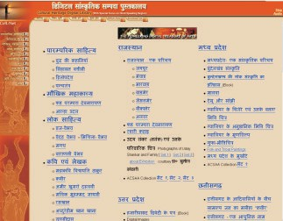

Type of Initiative: Digital Library

Implementing Agency: Cultural Informatics Laboratory, Indira Gandhi National Centre for the Arts (IGNCA), New Delhi, India

Supporting Agency: Ministry of Communications and Information Technology, Government of India

Web Address: <http://tdil.mit.gov.in/coilnet/ignca/welcome.html> Allied Projects:

•Kalasampada - Digital Library Resources of Indian Cultural Heritage (DL-RICH)

<http://www.ignca.nic.in/dlrich.html>

•Technology Development for Indian Languages Programme (TDIL) <http://tdil.mit.gov.in/>

15

•Content Development and IT Localisation Network Programme (CoIL-NET) <http://tdil.mit.gov.in/coilnet.htm>



•National Mission for Manuscripts [www.namami.or](http://www.namami.org/)[g; http://namami.nic.in](http://namami.nic.in/)

•Kritisampada: National Database of Manuscripts <http://www.namami.org/pdatabase.aspx>

##### Brief Description:

IGNCA has established another digital library on indigenous cultural heritage, i.e. the Cultural Heritage Digital Library in Hindi (CHDLH). This digital library has been developed under the auspices of the Content Development and IT Localization Network (CoIL-Net) programme with special focus on the Hindi-speaking region in India. CHDLH disseminates information and traditional knowledge related to:

•common heritage of the people;

•poetic and literary heritage;

•architectural heritage;

•natural heritage; and

•miscellaneous information related to other areas of arts, aesthetics and culture.

CHDLH also provides access to varieties of textual, graphical and multimedia digital resources, almost the same as documents available in DL-RICH, but localized in Hindi language.

Similar to DL-RICH, CHDLH provides browsing facilities through the hyper-linked index in the main page, index to thematic categories, and index to geographic categories. CHDLH does not have a search facility. The contents of CHDLH are developed mainly in Hindi and displayed in Devanagari scripts using Unicode.

16

### Digital e-Library



**(Dware Dware Gyan Sampadaa/ Providing Books at Your Doorsteps)**

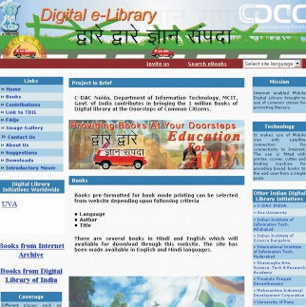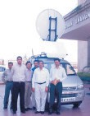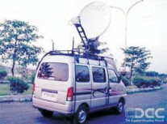

Figure 2: Mobile Van Reaching the Un-reached with Multilingual Digital Library Contents

17

Type of Initiative: Mobile Digital Library



Implementing Agency: Centre for Development of Advanced Computing, Noida (CDAC Noida)

Supporting Agency: Ministry of Communications and Information Technology, Government of India

Partner Institutions: Shri Shivanand, Sasta Sahitya Mandal, Digital Library of India Web Address (English): [http://mobilelibrary.cdacnoida.in](http://mobilelibrary.cdacnoida.in/)

Web Address (Hindi): <http://mobilelibrary.cdacnoida.in/indexHindi.html>

Allied Projects:

•Digital Library of India <http://www.dli.cdacnoida.in/>

•Cultural Heritage Digital Library in Hindi <http://tdil.mit.gov.in/coilnet/ignca/welcome.html>

•Technology Development for Indian Languages Programme (TDIL) <http://tdil.mit.gov.in/>

•Content Development and IT Localisation Network Programme (CoIL-NET) <http://tdil.mit.gov.in/coilnet.htm>

##### Brief Description:

The Centre for Development of Advanced Computing, Noida (CDAC Noida) has initiated a mission-mode project in bringing the one million books, available with the Digital Library of India portals, to the doorsteps of common citizens. Its Mission is “Internet enabled Mobile Digital Library brought to use of the common citizen for promoting literacy”. Different places such as schools in villages and other remote areas are covered under this programme to promote literacy and demonstrate the use of technology for masses, particularly in close proximity to the National Capital Region (NCR) and in particular states in northern and central India such as Delhi, Uttar Pradesh, Haryana, Madhya Pradesh, Himanchal Pradesh, Uttarakhand, Punjab, Rajasthan, and Bihar. The schools, adult learning centres, public libraries or local panchayats can invite this mobile digital library for accessing resources and services attached with the mobile unit. This initiative makes use of a mobile van with satellite connection for Internet connectivity. The van is fitted with necessary accessories for providing bound books to the end user from a single point. The mobile van is equipped with:

•Dish Antenna for Internet Connectivity

•Multimedia Laptop

•Laser Printer

•Scorer and Cutter

•Automatic Book Binder

Other than books available in Digital Library of India portals, some full-text e-books are also made available locally and in its portal in either one of DJVU, PDF and DOC formats. Some of the books are meant for neo-literates in spreading functional literary and lifelong learning in remote areas. The locally available e-books are written in Hindi language, as this initiative is covered in Hindi- speaking states only.

18

### Digital Library of India



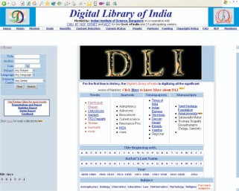

Type of Initiative: Digital Library

Principal Implementing Agency: Indian Institute of Science (IISc), Bangalore

Mega Scanning Centres: Indian Institute of Information Technology Hyderabad (IIIT Hyderabad); Centre for Development of Advanced Computing, Noida (CDAC Noida); Centre for Development of Advanced Computing, Kolkata (CDAC Kolkata)

Participating Institutions: Indian Institute of Information Technology Hyderabad; ERNET (Education and Research Network) India; Centre for Development of Advanced Computing (CDAC)

Supporting Agency (Indian): Ministry of Communications and Information Technology, Government of India

Supporting Agency (Overseas): National Science Foundation, USA

19

Web Address 1: [www.new.dli.ernet.in/](http://www.new.dli.ernet.in/) (Hosted by IISc)



Web Address 2: [www.dli.cdacnoida.in/](http://www.dli.cdacnoida.in/) (Hosted by CDAC Noida) Web Address 3: <http://dli.iiit.ac.in/> (Hosted by IIIT Hyderabad)

Alternative Web Addresses: Universal Digital Library/ Million Book Project

[http://tera-3.ul.cs.cmu.edu/ULIB/](http://tera-3.ul.cs.cmu.edu/ULIB) , [http://tera-3.ul.cs.cmu.edu/ULIB2/](http://tera-3.ul.cs.cmu.edu/ULIB2)

Allied Projects:

•Digital e-Library [http://mobilelibrary.cdacnoida.in](http://mobilelibrary.cdacnoida.in/)

•DL Gateway of ERNET <http://www.digitallibrary.ernet.in/>

##### Brief Description:

The Digital Library of India (DLI) is the greatest digital library initiative in South Asia, spreading all over the country and establishing a network of four mega scanning centres and 21 scanning centres, which feed the digital contents into the digital library systems. Dr. A.P.J. Abdul Kalam, the former President of India, launched portal of Digital Library of India on 8th September, 2003. DLI is a part of the Universal Digital Library (UDL) and Million Books Project, coordinated by the Carnegie Mellon University, USA. Although the original UDL project has already been concluded, the DLI project still ripples around with much acclamation, since the Ministry of Communications and Information Technology is supporting it. In this project, the former President of India is also personally interested, and provides digital content of his own writings. The Library of the honourable President's house is one of the scanning centres for DLI projects, where many invaluable rare books are being digitised. Presently DLI is available in three portals, hosted in three cities, i.e. Bangalore, Hyderabad and Noida. This initiative has become a test bed for many Indian language technology researches including the development of machine translation systems, optical character recognition (OCR) systems, summarizers, text-to-speech (TTS) systems and so on. DLI is also a huge repository for all major Indian languages, where many Indian language classics published before 1900 are freely available to global readers. The multilingual feature of this initiative is one of the strongest attributes for worldwide success of this project. Table 5 shows language-wise distribution of documents in DLI portal, hosted by IISc Bangalore. It shows that English language ranks first both in 2007 and 2006, whereas Telugu is ranks second and Hindi third in the consecutive years. It also shows that the books written in the top five languages, viz. English, Telugu, Hindi, Sanskrit and Urdu, cover more than ninety percent of the total available in this portal.

The structured metadata of scanned documents is created in the scanning centres of DLI, uploaded to DLI portals, and later searchable metadata provides access to full-text contents. DLI provides access to its resources through its search interface and browsing interface, available on the main page. The documents of DLI can be browsed by title of document (beginning alphabet to be chosen); author's last name (beginning alphabet to be chosen); range of years; subject; language; or name of scanning centre. Using a search interface available in the main page, the documents of DLI can be searched by the title of the document, name of author, subject, year, language, name of scanning centre, scanning location, name of vendor, or name of source library, if any of these

20

metadata elements are known. Two or more parameters can be given in a search query, and it will lead to the use of the Boolean operator AND. Other Boolean operators like OR, and NOT usually cannot be used in this search interface. The search result is displayed in the same window that lists the matched documents with the given query in multiple pages. Administrative and descriptive metadata is then displayed, when the user selects a particular document. The user can then browse the document page by page, either in image format (TIFF, GIF), or in text format (TXT, RTF, HTML, if the document is written in an European language).



Table 6 provides ranks of scanning centres based on their contribution to DLI project and in making digitized documents available in the DLI portal. This Table also shows that the Indian Institute of Information Technology, Allahabad; City Central Library, Hyderabad; Regional Mega Scanning Centre in the International Institute of Information Technology, Hyderabad; Tirumala Tirupati Devasthanams, Tirupati; and Arulmigu Kalasligam College of Engineering (AKCE), Madurai are the top five contributors to the DLI portal and accounted for 62.8 percent of total books available. Table 6 also indicates that some scanning centres have discontinued/ completed digitization works. Thus, the infrastructure, expertise and capacity developed in these scanning centres are now unutilized or under-utilized.

**Table 5: Language-wise Distribution of Books in DLI Portal**

|  |  |  |  |  |  |  |
| --- | --- | --- | --- | --- | --- | --- |
|  | **As on 24 Nov 2007** | | | **As on 10 Oct 2006** | | |
| **Language** | **2007**  **Rank** | **No. of Books** | **No. of Pages** | **2006**  **Rank** | **No. of Books** | **No. of Pages** |
| English | 1 | 68500 | 22432868 | 1 | 52614 | 18294974 |
| Telugu | 2 | 14090 | 2812929 | 2 | 14083 | 2811169 |
| Hindi | 3 | 10725 | 2820176 | 3 | 6897 | 1606422 |
| Sanskrit | 4 | 4532 | 1704528 | 5 | 2301 | 748545 |
| Urdu | 5 | 3803 | 916045 | 4 | 2977 | 719523 |
| Tamil | 6 | 1617 | 411723 | 6 | 1582 | 400632 |
| Persian | 7 | 1186 | 305769 | 7 | 1000 | 245727 |
| Marathi | 8 | 765 | 217204 | 11 | 446 | 118035 |
| Multilingual | 9 | 722 | 251158 | 8 | 653 | 230325 |
| Kannada | 10 | 680 | 169142 | 9 | 632 | 152839 |
| Arabic | 11 | 617 | 198552 | 10 | 617 | 198552 |
| Bengali | 12 | 423 | 222106 | 14 | 7 | 2237 |
| German | 13 | 134 | 52499 | 12 | 131 | 49675 |
| French | 14 | 81 | 32460 | 13 | 64 | 25517 |
| Portuguese | 15 | 6 | 3540 | - |  |  |
| Oriya | 16 | 5 | 6978 | 15 | 5 | 6978 |
| Spanish | 16 | 5 | 2555 | 15 | 5 | 17 |
| Italian | 18 | 3 | 1172 | 17 | 3 | 1172 |
| Greek | 19 | 2 | 949 | 18 | 1 | 539 |
| Gujarati | 19 | 2 | 357 | 18 | 1 | 52 |
| Others | - | 919 | 342751 | - | 876 | 291375 |
| **Total** |  | **108,817** | **32,905,461** |  | **84,895** | **25,904,305** |

21

**Table 6: Rank of Scanning Centres based on their Contributions**



|  |  |  |  |  |  |  |  |
| --- | --- | --- | --- | --- | --- | --- | --- |
| **Name of Scanning Centre** | **2007**  **Rank** | **No of Books** | **No of Pages** | **2006**  **Rank** | **No of Books** | **No of Pages** | **Remarks** |
|  | *As on 24/Nov/2007* | | | *As on 10/Oct/2006* | | |  |
| Indian Institute of Information  Technology, Allahabad | 1 | 24841 | 6055034 | 8 | 5536 | 1089457 |  |
| City Central Library,  Hyderabad | 2 | 12952 | 2762568 | 1 | 12952 | 2762568 | No Scanning  Activity in 2007 |
| Regional Mega Scanning  Centre, International Institute of Information Technology, Hyderabad | 3 | 11759 | 5121265 | 2 | 11759 | 5120717 | No Scanning Activity in 2007 |
| Tirumala Tirupati  Devasthanams, Tirupati | 4 | 11705 | 3019386 | 3 | 11705 | 2991711 | No Scanning  Activity in 2007 |
| Arulmigu Kalasligam College  of Engineering (AKCE), Madurai | 5 | 7095 | 1036014 | 4 | 7095 | 1036014 | No Scanning Activity in 2007 |
| State Central Library,  Hyderabad | 6 | 6479 | 2281804 | 5 | 6479 | 2218804 | No Scanning  Activity in 2007 |
| Salarjung Museum, Hyderabad | 7 | 6128 | 2339384 | 6 | 6128 | 2339384 | No Scanning  Activity in 2007 |
| Osmania University,  Hyderabad | 8 | 5779 | 1975659 | 7 | 5779 | 1975659 | No Scanning  Activity in 2007 |
| Rashtrapati Bhavan  (President’s House) Library | 9 | 4832 | 2023364 | 9 | 4832 | 2023364 | No Scanning  Activity in 2007 |
| IISc, Bangalore | 10 | 4418 | 1620729 | 10 | 4415 | 1620729 | No Scanning  Activity in 2007 |
| CDAC Kolkata | 11 | 3565 | 1621697 | - | N.A. | N.A. |  |
| Shanmugha Art, Science,  Technology & Research Academy (SASTRA), Tanjavur | 12 | 1872 | 577050 | 11 | 1874 | 577940 | No Scanning Activity in 2007 |
| Pune University | 13 | 1686 | 497074 | 12 | 1686 | 497074 | No Scanning  Activity in 2007 |
| Indian Institute of  Astrophysics, Bangalore | 14 | 1568 | 560577 | 13 | 1568 | 560577 | No Scanning  Activity in 2007 |
| Academy of Sanskrit Research (ASR), Melkote | 15 | 1297 | 394001 | 14 | 1138 | 344271 |  |
| Sringeri Sharada Peetham | 16 | 958 | 306439 | 15 | 819 | 259984 |  |
| Sri Venkateswara Oriental  Research Institute (SVORI), Tirupati | 17 | 495 | 216271 | 16 | 495 | 191224 | No Scanning Activity in 2007 |
| Digital Library, Mulund | 18 | 492 | 160185 | - | N.A. | N.A. |  |
| Bharatiya Jnanpith, Delhi | 19 | 292 | 92570 | 17 | 292 | 92570 | No Scanning Activity in 2007 |
| Anna University, Chennai | 20 | 247 | 122904 | - | N.A. | N.A. |  |
| Others |  | 357 | 121486 |  | 343 | 139258 |  |
| **Total** |  | **108,817** | **32,905,461** |  | **84,895** | **25,904,305** |  |

22

**HEC - National Digital Library**

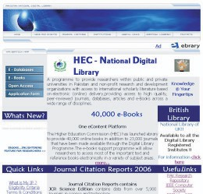

Type of Initiative: Digital Library

Principal Implementing Agency: Higher Education Commission, Pakistan Supporting Agencies: Higher Education Commission, Government of Pakistan

Participating/ Supporting Agencies (Overseas): International Network for the Availability of Scientific Publications (INASP), UK; eBrary, USA; British Library, UK

Web Address: <http://www.digitallibrary.edu.pk/>

Allied Project: Pakistan Research Repository (PRR) [www.eprints.hec.gov.pk](http://www.eprints.hec.gov.pk/)

##### Brief Description:

The Higher Education Commission (HEC) is an apex body for the higher education system in Pakistan that forges the transformation of indigenous universities in Pakistan into a world-class centre of education, research and development. Through facilitating this process, the HEC is spearheading the building of a knowledge-based economy in Pakistan. HEC-National Digital

23

Library is a national programme to strengthen access to subscription-based scholarly literature and databases, where every researcher attached to a private/public sector university or non-profit research institution gets online access to international scholarly literature, such as, high quality peer-reviewed journals, online databases and e-books across a wide range of disciplines. HEC has launched *Ebrary* to provide 40,000 online books in addition to 23,000 journals that have been made available through this Digital Library Programme. The e-books support programme allows researchers to access most of the important text and reference books electronically in a variety of subject areas. This follows consortia-based subscription model, where the Government of Pakistan in collaboration with some international agencies, generously supports this programme. HEC also promotes open access to public-funded research results through its Pakistan Research Repository.

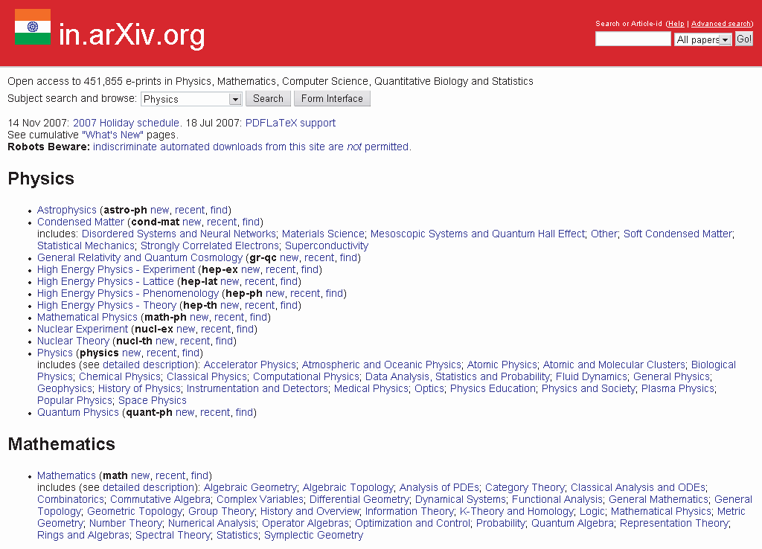

### in.arXiv, hosted by Institute of Mathematical Sciences, Chennai

24

Type of Initiative: Digital Library



Principal Implementing Agency: Institute of Mathematical Sciences, Chennai Partner Institution: Cornell University Library, USA

Supporting Agency (Overseas): National Science Foundation, USA; Cornell University, USA Software Used: EPrints

Web Address 1: <http://in.arxiv.org/> (Hosted by IMSc, Chennai)

Web Address 2: <http://xxx.imsc.res.in/> (Hosted by IMSc, Channai)

Web Address 3: <http://www.arxiv.org/> (Hosted by Cornell University Library, USA)

##### Brief Description:

The Institute of Mathematical Sciences (IMSc), founded by Alladi Ramakrishnan in 1962, is a national institution for fundamental research in the area of mathematical and physical sciences. Since 1997, IMSc hosts a mirror site of the arXiv, a resourceful open access archive in the fields of physics, mathematics, non-linear science, computer science, quantitative biology and statistics, developed by Cornell University Library. The researchers across the world are responsible for phenomenal growth of this digital archive through submission of their own research publications. The contents of arXiv conform to academic standards, as set out by Cornell University, USA. It is owned, operated and funded by Cornell University, a private not-for-profit educational institution. It is also partially funded by the National Science Foundation in collaboration with local support from the Institute of Mathematical Sciences, Chennai. Thus, IMSc became the pioneer in open access archiving in India, although having limited storage capacity and bandwidth connectivity at that point of time. This repository is compliant to OAI-PMH (Protocol for Metadata Harvesting) and indexed in the OAIster, Google Scholar, OpenDOAR (Directory of Open Access Repositories) and other harvesters.

25

### India Education Digital Library

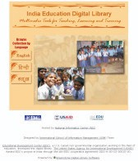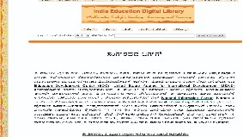

Figure 3: India Education Digital Library – Telugu Interface

26

Type of Initiative: Digital Library



Principal Implementing Agency: Education Development Center (EDC), Bangalore Participating Institutions (Indian): International School of Information Management (iSIM), University of Mysore; National Informatics Centre, Karnataka

Supporting Agency (Overseas): United States Agency for International Development (USAID) Software Used: Greenstone Digital Library Software

Web Address: <http://www.edudl.gov.in/>

##### Brief Description:

The India Education Digital Library, hosted by the National Informatics Centre in Bangalore and designed by the International School of Information Management (iSIM) team, is a Greenstone- based digital library. It comprises multimedia tools for teaching, learning and training. This was initially developed as an online multilingual digital library available in three languages - English, Kannada or Hindi. Later, a CD-ROM version was developed having identical digital resources, as available in online version. The main focus of this digital library is the government-aided primary and secondary schools in India. The digital library consists of 450 radio programmes, video films and learning contents. The contents in the digital library cater to students studying in classes I to VIII in the subjects of mathematics, social studies, sciences, environmental science and languages such as English, Hindi and Kannada. Azim Premji Foundation (APF), Confederation of Indian Industry (CII) Shiksha, Directorate of State Education Research and Training (DSERT) Karnataka, Digital Study Hall and EDC have provided content to the digital library. Users of this digital library can search the website for content by the keyword, subject, title, language, audience and type of media. Afterwards they can directly access searched contents from the website.

27

### Indian National Digital Library in Engineering Sciences and Technology (INDEST) Consortium

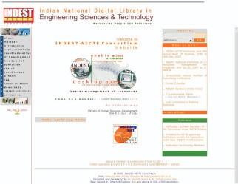

Type of Initiative: Digital Library

Principal Implementing Agency: Indian Institute of Technology Delhi (IITD), New Delhi Supporting Agencies: All India Council for Technical Education (AICTE), Ministry of Human Resource Development (MHRD), Government of India

Web Address: <http://indest.iitd.ac.in/> Allied Projects:

•EPrints and ETD at Indian Institute of Technology Delhi

[http://eprint.iitd.ac.in/dspace/](http://eprint.iitd.ac.in/dspace)

•IRs@Member Institutions <http://indest.iitd.ac.in/oaeresources.html#IRs>

28

##### Brief Description:

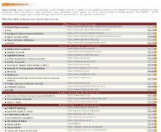

The Indian National Digital Library in Engineering Sciences and Technology (INDEST) Consortium is a national information infrastructure programme, established for strengthening access to subscription-based electronic information resources and capacity enhancement of information infrastructure in Indian academic institutions imparting professional education and research in the areas of engineering, technology and management sciences. The electronic journal publishers negotiate with the INDEST Consortium for providing access to full-text content to member institutions. This follows consortia-based the discounted rates of subscription model, where both publishers and institutions may benefit. The Ministry of Human Resource Development (MHRD) provides funds required for subscription to electronic resources for 37 core member institutions including IISc, IITs, NITs, IIMs and a few other centrally-funded government institutions. Besides, AICTE provides funds required for subscription to electronic resources for 60 government-aided engineering colleges and technical departments in universities. Another 524 AICTE-accredited and UGC-affiliated self-supported institutions have recently joined this umbrella consortium through an INDEST-AICTE joint initiative whereby highly discounted rates of subscription for electronic scholarly literature and better terms of agreement with the publishers are obtained. The Consortium provides continuous training support to member institutions and their user communities, in different metro cities. The INDEST Consortium strongly encourages open access to public-funded research results through institutional repositories in its member institutions. Many member institutions have already established institutional, and electronic theses and dissertations (ETD) repositories to make their research results available in public domain (see: [http://indest.iitd.ac.in/oaeresources.html).](http://indest.iitd.ac.in/oaeresources.html)

Figure 4: Links to Indian and International Open Access Resources at INDEST Consortia Gateway

29

#### Kalasampada: Digital Library - Resources of Indian Cultural Heritage (DL-RICH)

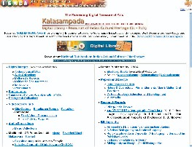

Type of Initiative: Digital Library

Implementing Agency: Cultural Informatics Laboratory, Indira Gandhi National Centre for the Arts (IGNCA), New Delhi, India

Supporting Agency: Ministry of Communications and Information Technology, Government of India

Web Address: <http://www.ignca.nic.in/dlrich.html> Allied Projects:

•Cultural Heritage Digital Library in Hindi <http://tdil.mit.gov.in/coilnet/ignca/welcome.html>

•Technology Development for Indian Languages Programme (TDIL) <http://tdil.mit.gov.in/>

•Content Development and IT Localisation Network Programme (CoIL-NET) <http://tdil.mit.gov.in/coilnet.htm>

30

•National Mission for Manuscripts [www.namami.or](http://www.namami.org/)[g; http://namami.nic.in](http://namami.nic.in/)



•Kritisampada: National Database of Manuscripts <http://www.namami.org/pdatabase.aspx>

##### Brief Description:

The Indira Gandhi National Centre for the Arts (IGNCA) has established a digital library on indigenous cultural heritage, i.e. 'Kalasampada: Digital Library Resource for Indian Cultural Heritage' (DL-RICH) with the support from India's Ministry of Communications and Information Technology. Since its inception, DL-RICH is recognized as a reference databank for cultural heritage of India to encompass and preserve the distributed fragments of Indian arts, aesthetics and culture. This huge knowledge base helps the scholars to explore and visualize the information stored in multiple layers. DL-RICH provides online access to digital images of cultural heritage resources such as manuscripts, rare photographs, rare books, rare painting, sculptures, handicrafts, monuments, artifacts, festivals, as well as varieties of textual, graphical, audio-visual and multimedia resources. Kalasampada received the 'Golden Icon: Award for Exemplary Implementation for e-Governance Initiatives' under the category, Best Documented Knowledge and case study, given by India's Department of Administrative Reforms and Public Grievances in 2005. It hosts a Sanskrit text repository, called Gaudiya Grantha Mandira, that covers more than 400 chapters from different oriental texts. The digital corpus in this knowledge base includes over

0.5 million folios of manuscripts, slides, digitized photographs, IGNCA published books, periodicals 'Kalakalp' and 'Vihangama', over 400 hours of audio and video, and approximately 50 walkthroughs. Some of the documents in the collections are not available to the open access domain due to copyright restrictions.

DL-RICH can be navigated through the hyper-linked indexes in the main page, thematic categories, and, geographic categories. The index to thematic categories gives further links to documents pertaining to literature, personalities, catalogues, performances, studies, events, heritage, collections, religious categories, etc. The index to geographic categories gives further links to states and union territories of India, and other countries. Although DL-RICH does not provide a comprehensive search facility, user-friendly interfaces in this portal make navigation convenient to the general users.

31

### Muktabodha: Digital Library and Archiving Project

Type of Initiative: Digital Library

Principal Implementing Agency: Muktabodha Indological Research Institute, New Delhi Participating Institution (Indian): French Institute of Pondicherry (IFP)

Participating Institution (Overseas): Ecole française d'Extrême-Orient (EFEO) Supporting Agency (Overseas): SYDA Foundation, USA

Web Address [1: http://www.muktabodhalib.org/digital_library.htm](http://www.muktabodhalib.org/digital_library.htm)

Web Address 2: Related Projects:

<http://www.muktabodhalib.org/SECURE/digital_library_index.htm>

•National Mission for Manuscripts [www.namami.or](http://www.namami.org/)[g; http://namami.nic.in](http://namami.nic.in/)

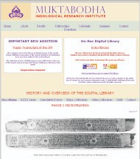

•Kritisampada: National Database of Manuscripts <http://www.namami.org/pdatabase.aspx>

32

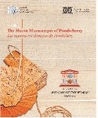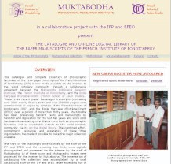

Figure 5: Information Brochure of the Shaiva Manuscripts of Pondicherry, an inscription on the Memory of the World Register

Figure 6: Paper Transcripts of Shaiva Manuscripts of Pondicherry in Muktabodha Collection



##### Brief Description:

The Muktabodha Digital Library and Archiving Project is an important indigenous digital library project in India initiated by Muktabodha Indological Research Institute in July 2003. This digital library is open access to the public for non-commercial purposes only. It is functioning as a source of Indological texts for individual scholars and institutions across the world that makes available core texts of oriental literature. Muktabodha plans to make this digital library a repository of core texts of different branches of Shaivism. Muktabodha collaborates with other oriental research institutions in India for digitizing their rare books and manuscripts, which have been added here in phases.

Although this digital library does not provide a comprehensive search facility, Muktabodha provides easy browsing facilities for its core online collections by the hyper-linked indexes, such as title of texts, name of authors or commentators, and volume number. Then the chapters of each volume will appear followed by the main texts in Sanskrit or English. The Sanskrit text may contain digitized images of pages. Some texts of this collection are available in DjVu or PDF format.

33

The online collections of Muktabodha are briefly described below:

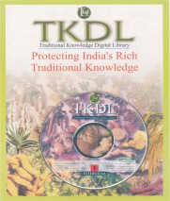

•Paper Transcripts of Shaiva Siddhanta, from the French Institute of Pondicherry (inscribed on UNESCO Memory of the World Register), having collection size over 210,000 digitized pages in over 2,000 texts. User registration is required for online access of this special collection**.**

•Vedic Manuscripts of Gokarna (palm-leaf manuscripts in Grantha script)

•Devakottai Series (24 volumes of the Shaiva Siddhanta Paripalana Sangha Devakottai Series mostly in the South Indian scripts)

•Tantric searchable e-texts from different printed editions

•Kashmir Series of Texts and Studies (75 volumes texts of the Kashmir Shaivism)

### Traditional Knowledge Digital Library

34

Type of Initiative: Digital Library



Principal Implementing Agency: National Institute of Science Communication and Information Resources (NISCAIR), Council of Scientific and Industrial Research (CSIR), New Delhi

Participating Institutions: Council of Scientific and Industrial Research (CSIR), Ministry of Science and Technology, Government of India; Controller General of Patents Designs and Trademarks, Department of Industrial Policy and Promotion, Ministry of Commerce and Industry, Government of India; SAARC Documentation Centre, India

Supporting Agency: Department of Ayurveda, Yoga, Naturopathy, Unani, Siddha and Homoeopathy (AYUSH), Ministry of Health and Family Welfare, Government of India

Web Address: [www.tkdl.res.in](http://www.tkdl.res.in/) Allied Projects:

•National Science Digital Library; Comprehensive Traditional Knowledge Digital Documentation and Library <http://www.csir.res.in/External/Heads/aboutcsir/network_projects.htm>

•CSIR E-Journals Consortium <http://202.54.99.7/ejournal/ejournalhome1.htm>

•National Science Digital Library <http://www.csir.res.in/External/Heads/aboutcsir/network_projects.htm>

##### Brief Description:

The Traditional Knowledge Digital Library (TKDL) is well-known Indian digital library initiative, being implemented by the National Institute of Science Communication and Information Resources (NISCAIR). TKDL aims at preventing the misappropriation of traditional knowledge of India and some other south Asian countries through an appropriate arrangement with national and foreign patent offices. TKDL is available in five official languages of the United Nations, namely, English, Japanese, German, French and Spanish. TKDL targets codified information on the Indian systems of medicine, namely, Ayurveda, Unani, Siddha, Yoga, Naturopathy, and tribal medicine. TKDL has already documented traditional medicinal formulations comprising 13 million A4 size pages of data on transcribed 62,000 formulations in Ayurveda, 60,000 formulations in Unani, and 1,300 formulations in Siddha. TKDL is now documenting more formulations from different Ayurvedic, Unani and Siddha texts, whereas formulations from other Indian systems of medicine,

e.g. Yoga, Naturopathy, tribal medicine, etc. will be added in near future.

At the core of the TKDL project is the innovative approach in the form of Traditional Knowledge Resource Classification (TKRC) that enables structured classification for the purpose of systematic arrangement, dissemination and retrieval of formulations described in classical texts of Ayurveda, Unani and Siddha, into patent compatible format compatible to the International Patent Classification (IPC) code. TKRC has been evolved for about 5000 sub-groups against earlier one sub-group in International Patent Classification. The TKDL provides different kinds of searching facilities such as simple search, advance search and advance query. Simple search lets the user search on the exact keyword. Advance search lets the user search by any element like keyword, title, International Patent Classification (IPC) code, name of disease, etc. Boolean operators like AND, OR, NOT, NEAR can also be used for combination of search terms. It also allows entering queries

35

with left and right truncation, using asterisks in front or in the end of the word, phrase, Sanskrit name, etc. An Advance query lets the user search by any or more than one key terms as the keyword, IPC code, title, bibliographic reference, or name of disease, then restrict the display of the search r e s u l t s . T K R C c a n b e n a v i g a t e d f r o m t h e s e c t i o n t o s u b g r o u p (Section>Class>Subclass>Group>Subgroup). Each formulation is displayed in a page, titled “Key attributes of TKDL,” with attributes like formulation number, title of traditional knowledge resource, knowledge known since which year, TKRC code, IPC code, details of process / formulation, list of documents with date of publication (prior art). This page gives links to actual citation/slokas (prior art) and images of compositions.

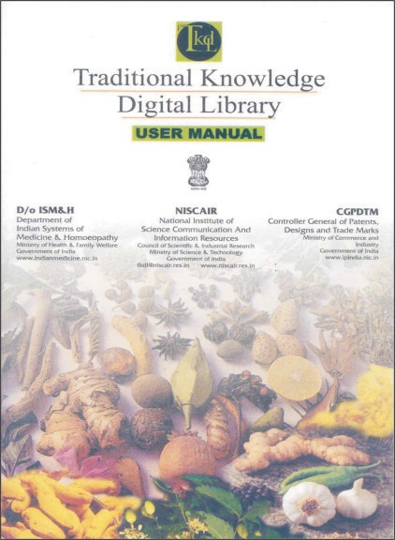

TKDL has been receiving wide international coverage. This has been publicized most as compared to other digital library initiatives in India. TKDL is widely acknowledged by the World Intellectual Property Organization (WIPO) and its member countries. The International Patent Offices have direct access to TKDL for preventing the misappropriation of traditional knowledge of India. The SAARC Documentation Centre in New Delhi is also currently engaged in the establishment of TKDL for SAARC nations.

Figure 7: TKDL User Manual

36

### United Nations Digital Library, Islamabad, Pakistan

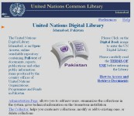

Type of Initiative: Digital Library

Principal Implementing Agency: United Nations Common Library, United Nations Information Center (UNIC), Islamabad, Pakistan

Supporting Agencies: United Nations Organizations in Pakistan Software Used: Greenstone Digital Library Software

Web Address: <http://library.un.org.pk/gsdl/cgi-bin/library.exe>

##### Brief Description:

The United Nations Digital Library is an online repository of the full-text digital documents of the various United Nations agencies, Programmes and Funds, having country offices in Pakistan. This is part of United Nations Common Library in Pakistan that systematically facilitates the retention and long-term preservation of UN documents, in a usable form. The collection of this digital library comprises the general documents, reports, publications, newsletters, press releases and other public information items. This portal offers an efficient browsing and searching facility and easy access to required information. The online collection can be navigated by 21 broad subject headings, names of UN agencies, keywords, and titles of the documents. This archive also has facility of full-text searching, and can be searched by title of document, document sections, section titles, keyword, organization and subject. The UN agencies and their partner organizations are continuously archiving their publications and key documents on development issues in this repository to showcase, share and preserve their published works as well as disseminate them in much faster, easier, more varied ways, to a wider range of audience.

37

### Vidyanidhi

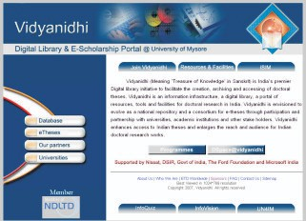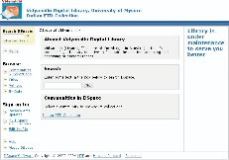

38

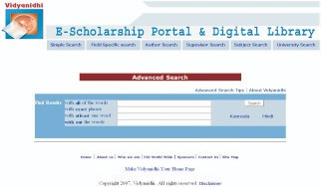

Type of Initiative: Digital Library / Electronic Theses and Dissertations (ETD) Principal Implementing Agency: University of Mysore, Mysore

Supporting Agencies: National Information System for Science and Technology (NISSAT), Department of Scientific and Industrial Research (DSIR), Government of India; Ford Foundation; Microsoft India

Software Used: DSpace

Web Address [1: www.vidyanidhi.org.in](http://www.vidyanidhi.org.in/)

Web Address [2: http://dspace.vidyanidhi.org.in:8080/dspace](http://dspace.vidyanidhi.org.in:8080/dspace) Web Address 3: <http://210.212.200.226/>

Related Projects:

•ETD @ IISc [http://eprints.iisc.ernet.in](http://eprints.iisc.ernet.in/)

•CSIR Explorations [http://csirexplorations.com](http://csirexplorations.com/)

•DSpace at National Chemical Laboratory <http://dspace.ncl.res.in/dspace>

##### Brief Description:

The Vidyanidhi is a national digital library for electronic theses and dissertations (ETD), initiated by the University of Mysore and supported by the Department of Scientific and Industrial Research (DSIR), Ford Foundation and Microsoft India. Vidyanidhi aims at enhancing visibility of Indian doctoral research through archiving and disseminating doctoral dissertations of researchers

39

submitted in Indian universities to a global audience. This is a national level repository, covering major Indian universities. Vidyanidhi established an official partnership with Jadavpur University, University of Hyderabad, University of Kashmir, Jamia Millia Islamia and National Social Science Documentation Centre (NASSDOC). Other universities of India also have taken part in this initiative. Vidyanidhi maintains mainly two kinds of databases, a bibliographic database and a full- text repository using DSpace software. Its bibliographic database has interfaces for simple search, advanced search, field-specific search, subject search, supervisor search, author search, and search in Indian Languages Kannada/Hindi. The search results display the following metadata: Title, Creator (Author), Subject, Contributor (Supervisor), Language, Degree Grantor and Year. Vidyanidhi also maintains an experts' database, where details of university faculties can be searched by the name of the guide or research area. Although, Vidyanidhi has digitization facilities and infrastructure, some of its partner universities don't have such digitization facilities. Thus, the collection of Vidyanidhi grows only when it shares its physical facilities with other universities, which is not practically feasible in a vast country like India. Till date, most of the universities in India do not insist that researchers submit electronic copies of doctoral theses, either on CD-ROM or online. If electronic copies of doctoral theses are available to partner universities, they could immediately be uploaded to the Vidyanidhi ETD database. The electronic theses repository can be browsed by name of the communities, name of collections, title of theses, name of researchers/authors, and by date. This repository can be searched by any metadata element or combination of elements (using Boolean operators), such as keywords, subject, title of theses, name of the researcher and name of the university. The information retrieved from the execution of a search query leads to retrieval of full-text contents of theses. Vidyanidhi is listed in and harvested by many online directories and metadata harvesters such as Google Scholar, OAIster, OpenDOAR, and CASSIR.



40

### Vigyan Prasar Digital Library



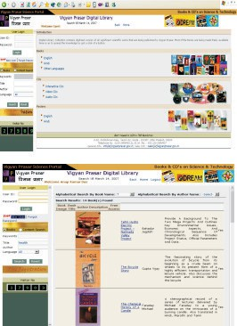

41

Type of Initiative: Digital Library



Principal Implementing Agency: Vigyan Prasar, Noida

Participating Institutions: National Council for Science & Technology Communication (NCSTC), New Delhi; NCSTC Network, Delhi; National Children's Science Congress Supporting Agency: Department of Science & Technology, Government of India

Web Address 1: [http://www.vigyanprasar.gov.in/digilib/](http://www.vigyanprasar.gov.in/digilib)

Web Address [2: http://www.vigyanprasar.gov.in/dream/index.asp](http://www.vigyanprasar.gov.in/dream/index.asp)

##### Brief Description:

Vigyan Prasar, established in 1989 as an autonomous society under the Department of Science and Technology (DST), undertakes large scale science popularization tasks in the country. Popular science books and periodical 'Dream 2047', published by Vigyan Prasar, are well accepted by the science communicators and popular science activists in India and other South Asian countries. Vigyan Prasar maintains a network of science clubs, popularly known as VIPNET, across the country for propagating scientific temperament among the youths and school children. Through its regular publications, activity kits and other information materials, Vigyan Prasar encourages children, youth and adult citizens to think scientifically and act scientifically, by reviving their inquisitiveness, curiosity and the habit of asking questions whenever they don't know or don't understand. Vigyan Prasar Science Portal, maintained by Vigyan Prasar Information System (VIPRIS), aims to provide updated information for anything and everything on science from India. Vigyan Prasar maintains an open access digital library to spread scientific knowledge, where the digital collection contains digitized full-text versions of all significant scientific works that are being published by Vigyan Prasar. So far, 72 books in English, 42 books in Hindi and 17 books in other languages are available in this digital library. The books in this digital library can be searched by keywords, title of the book, name of the author and language. *Dream 2047*, a popular science magazine and an open access periodical, is also archived in Vigyan Prasar Science Portal from volume one.

42



**OPEN COURSEWARE INITIATIVES**

43

### CEC Learning Object Repository

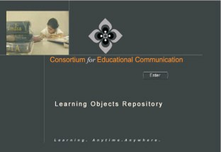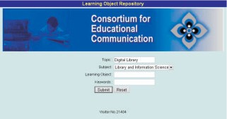

44

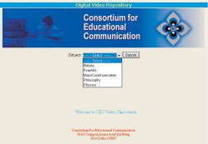



Type of Initiative: Open Courseware/ Learning Object Repository

Principal Implementing Agency: Consortium for Educational Communication (CEC), New Delhi

Partner Institutions: University Grants Commission (UGC), Educational Multimedia Research Centres (EM2RC), Audio Visual Research Centre (AVRC), Vyas Channel on Gyan Darshan (24 hours Higher Educational Channel)

Supporting Agency: Ministry of Human Resource Development, Government of India Web Address [1: www.cec-lor.edu.in](http://www.cec-lor.edu.in/)

Web Address [2: www.cec-lor.edu.in/search.asp](http://www.cec-lor.edu.in/search.asp)

Allied Projects:

* CEC Digital Video Repository [www.cec-lor.edu.in/dvr/](http://www.cec-lor.edu.in/dvr)
* [CEC E-Content Development - E-Learning Resources for Undergraduates www.cec- econtent.edu.in/](http://www.cec-lor.edu.in/dvr)
* Web casting/ Multicasting of Vyas Channel [http://202.41.99.76/](http://www.cec-econtent.202.41.99.76/)

##### Brief Description:

Consortium for Educational Communication (CEC) is an inter-university centre on electronic media, established by the University Grants Commission (UGC). The CEC in coordination with its 17 Educational Multimedia Research Centres, has been producing television programmes in various subject categories in English, Hindi and regional languages. Some of

45

the audio-visual programmes are based on syllabus-based topics at the school, polytechnic, college and university levels. Produced educational programmes are broadcast on the national educational television channels such as Vyas Higher Education Channel, Gyan Darshan, and Doordarshan. All produced educational programmes are being regularly quality-checked before the telecast at CEC. To check the quality of the programmes produced by educational media centres and CEC, regular Preview Committee meetings are organized in various subject categories where experts are called to review programmes, which are then revised by the respective Centre before the telecast, based on comments from the Committee. The television programmes produced in CEC and broadcasted in educational channels are reusable. Thus, CEC established the Learning Object Repository (LOR) and the Digital Video Repository (DVR) to provide worldwide access to these qualitative learning resources. The LOR is a bank of short duration reusable learning objects for special benefits to students and teachers for face to face learning as well as to other users globally. The streaming video technique is used for online viewing of these learning objects. The LOR portal can be searched by subject, topic, title of the learning object, and keywords. This portal can also be navigated through subject categories.

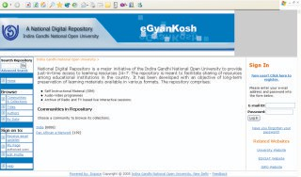

### eGyankosh - A National Digital Repository

46

Type of Initiative: Open Courseware



Principal Implementing Agency: Indira Gandhi National Open University (IGNOU), New Delhi Partner Institutions: Distance Education Council; India EDUSAT

Supporting Agency: Ministry of Human Resource Development, Government of India Web Address: [www.egyankosh.ac.in](http://www.egyankosh.ac.in/)

Software Used: DSpace

Allied Project: Sakshat, One Stop Portal on Indian Education [www.sakshat.ac.in](http://www.sakshat.ac.in/)

##### Brief Description:

Indira Gandhi National Open University (IGNOU) is a mega open university that offers distance and open education to millions of learners in India and other countries. IGNOU produces self- instructional study materials for various programmes and also hosts a number of educational broadcasting channels. IGNOU has initiated the establishment of a National Digital Repository of learning resources *eGyankosh*. This repository envisages to store, index, preserve, distribute and share the digital learning resources of open and distance learning (ODL) institutions in the country:

The repository supports seamless aggregation and integration of learning resources in different formats such as self-instructional study materials, audio-video programmes, and archives of radio and television-based live interactive sessions. The repository facilitates any time access to its collections (24×7×365), offering interoperability and federated searching facility. The decentralized model of the repository supports multiple submission points facilitating submission of content from remote locations. The collection can be searched and browsed by subject, title, and author.

Presently, this repository has two communities, i.e. India and the Pan African e-Network. The *India* community has sub-communities, based on different academic divisions in IGNOU such as School of Agriculture, School of Computer and Information Sciences, School of Continuing Education, School of Education, School of Engineering and Technology, School of Health Sciences, School of Humanities, School of Law, School of Management Studies, School of Sciences, and School of Social Sciences. Under each sub-community, the user can get online access to full-text content of self-instructional study materials offered by this academic division. The community *Pan African e- Network* provides access to self-instructional study materials of the Master of Business Administration (MBA) programme.

47

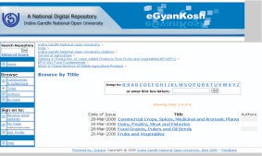



Figure 8: Browse by Title of Self-Learning Study Materials

### Indo-German eGurukul on Digital Libraries

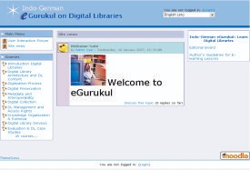

48

Principal Implementing Agency: Documentation Research and Training Centre (DRTC), Indian Statistical Institute, Bangalore



Supporting Agency: Goethe-Institut in New Delhi Software Used: Moodle

Web Address: [http://drtc.isibang.ac.in/mmb/](http://drtc.isibang.ac.in/mmb) Allied Projects:

•Librarians' Digital Library [https://drtc.isibang.ac.in](https://drtc.isibang.ac.in/)

•Search Digital Libraries <http://drtc.isibang.ac.in/sdl>

•DLRG - Digital Library Research Group (a Discussion Forum) <http://drtc.isibang.ac.in/mailman/listinfo/dlrg>

•Sankhya, the Indian Journal of Statistics (an Open Access Journal) [http://sankhya.isical.ac.in](http://sankhya.isical.ac.in/)

##### Brief Description:

The Indo-German eGurukul on Digital Libraries is a collaborative project of DRTC and Goethe- Institut in New Delhi to facilitate self-paced learning on digital libraries. Presently this e-learning portal has the following modules:

•Introduction to Digital Libraries

•Digital Library Architecture and Digital Library Content

•Digitization Process

•Digital Preservation

•Metadata and Interoperability

•Digital Collection

•Digital Library Management and Access Rights

•Knowledge Organization and Retrieval

•Digital Library Services

•Evaluation and Digital Library Case Studies

The Indian digital library experts, in collaboration with their German counterparts, have developed the content of these modules. Users follow a free registration process for access to different learning modules and participation in the User Interaction Forum.

49

### National Programme on Technology Enhanced Learning (NPTEL)



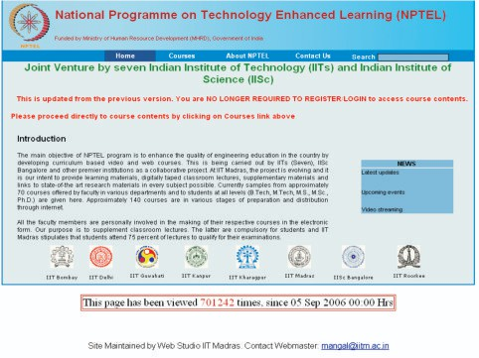

Type of Initiative: Open Courseware

Principal Implementing Institutions: Indian Institute of Technology Madras (Web Coordinator); Indian Institute of Technology Delhi (Video Coordinator)

Participating Institutions: Indian Institutes of Technology (seven IITs such as IIT Bombay, IIT Delhi, IIT Guwahati, IIT Kanpur, IIT Kharagpur, IIT Madras, and IIT Roorkee) and Indian Institute of Science (IISc), Bangalore

Supporting Agency: Ministry of Human Resource Development (MHRD), Government of India

Web Address: [www.nptel.iitm.ac.in,](http://www.nptel.iitm.ac.in/) [http://youtube.com/nptelhrd/](http://youtube.com/nptelhrd)

##### Brief Description:

This is an open courseware initiative by seven Indian Institutes of Technology (IITs) and the Indian Institute of Science (IISc). The main objective of this programme is to enhance the quality of

50

engineering education in the country by developing more than 200 curricula-based video and web courses. Premier institutions of India are participating in this innovative programme for the production and dissemination of quality courseware in the areas of engineering and technology. Already a number of open courseware is now available through its website. A discussion forum for each web course is available. The open courseware and discussion threads can be accessed through the user-friendly portal interface. The video courses are at first broadcast through the Eklavya Technology Channel a technical education channel for television. This Initiative has constituted six Engineering Groups which are responsible for production of video courseware:

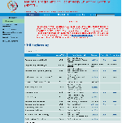

•Civil Engineering Group

•Computer Science and Engineering Group

•Core Science and Engineering Group

•Electrical Engineering Group

•Electronics and Communication Engineering Group

•Mechanical Engineering Group

The programme is systematically structured through the Technology Enhanced Learning (TEL) Committee, Programme Implementation Committee (PIC), National Programme Committee (NPC) and subject-level Expert Groups at the national level and institutional levels. This programme addresses harmonization of engineering curricula across the country as well as the shortage of quality teaching faculty at the second and third tier (i.e., government-supported and self-supported) institutions.

Figure 9: Navigating Web-Based Open Courseware in NPTEL

51

### NCERT Online Textbooks



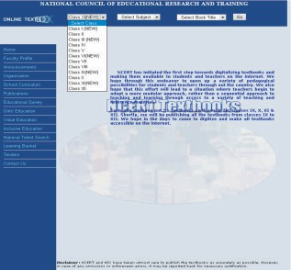

Type of Initiative: Open Courseware

Principal Implementing Agency: National Council of Educational Research and Training (NCERT), New Delhi

Supporting Agency: Ministry of Human Resource Development, Government of India Web Address [1: http://www.ncert.nic.in/textbooks/testing/Index.htm](http://www.ncert.nic.in/textbooks/testing/Index.htm)

Web Address [2: http://www.ncert.nic.in/textbooks/backup/index.htm](http://www.ncert.nic.in/textbooks/backup/index.htm)

Allied Project: Sakshat, one stop portal on Indian Education [http://www.sakshat.ac.in](http://www.sakshat.ac.in/)

52

##### Brief Description:

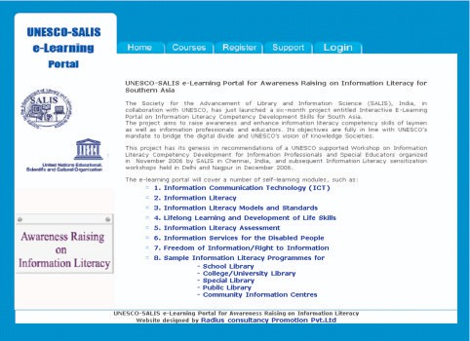

NCERT is an apex resource organization set up by the Government of India to assist and advise the Central and State Governments on academic matters related to school level education. NCERT publishes school textbooks, mainly in English, Hindi and Urdu. It has initiated a step towards making school textbooks freely available on the Internet for students and teachers through its website [(www.ncert.nic.in).](http://www.ncert.nic.in/) Most of the textbooks available in this portal are in new edition, based on the *National Curriculum Framework 2005*. The educational planners in NCERT expect that a variety of pedagogical possibilities would open up for students and teachers across the country through this initiative. It is also expected that this effort will lead to a situation where teachers begin to adopt a more modular approach, rather than a sequential approach to teaching and learning, through online access to a variety of teaching and reference materials. This portal provides easy navigation to textbook chapters by title/subject of the book for a particular class. The textbooks available here are written in English, Hindi and a few in Urdu.

### UNESCO-SALIS e-Learning Portal

53

Principal Implementing Agency: Society for the Advancement of Library and Information Science (SALIS), India



Supporting Agency: UNESCO Office in New Delhi Software Used: Moodle

Web Address: <http://salisonline.org/> Allied Programme:

* IFLA/UNESCO Information Literacy Resources Directory [www.infolitglobal.info](http://www.infolitglobal.info/)
* Information for All Programme (IFAP) [http://portal.unesco.org/ci/en/ev.php-](http://portal.unesco.org/ci/en/ev.php-URL_ID%3D21293%26URL_DO%3DDO_TOPIC%26URL_SECTION%3D201.html) [URL_ID=21293&URL_DO=DO_TOPIC&URL_SECTION=201.html](http://portal.unesco.org/ci/en/ev.php-URL_ID%3D21293%26URL_DO%3DDO_TOPIC%26URL_SECTION%3D201.html)

##### Brief Description:

The UNESCO-SALIS e-Learning Portal is a collaborative project of the Society for the Advancement of Library and Information Science (SALIS) and UNESCO office in New Delhi. The project aims to raise awareness and enhance information literacy competency skills of laymen as well as information professionals and educators in the South Asian sub-region. Its objectives are fully in line with UNESCO's mandate to bridge the digital divide and UNESCO's vision of knowledge societies. Presently this e-learning portal has the following modules:

1. Information Communication Technology (ICT)
2. Information Literacy
3. Information Literacy Models and Standards
4. Lifelong Learning and Development of Life Skills
5. Information Literacy Assessment
6. Information Services for the Disabled People
7. Freedom of Information/Right to Information
8. Sample Information Literacy Programmes for
   * School Library
   * College/University Library
   * Special Library
   * Public Library
   * Community Information Centres

The information literacy competency skills imparted here, have been derived from the existing international standards, adopted by the UNESCO, the International Federation of Library Associations and Institutions (IFLA), American Library Association (ALA), and other professional societies. Indian library experts, in collaboration with lifelong learning experts, have developed the content of the modules in this eLearning portal. In order to access the different learning modules and participate in the Course Discussion Forum, a first-time user should opt for the user registration process. The learning system generates the unique login name and password which are required for subsequent access.

54

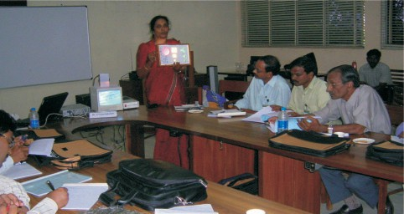

Figure 10: Special Devices for Accessing Information demonstrated at the SALIS Information Literacy Workshop 2006

55



**OPEN ACCESS JOURNALS**

56

### e-Journals @ INSA

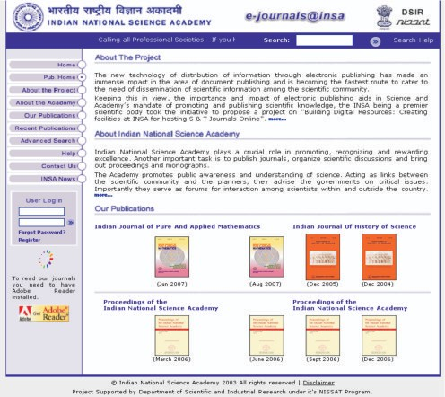

Type of Initiative: Open Access Journals

Principal Implementing Agency: Indian National Science Academy (INSA), New Delhi

Supporting Agency: National Information System for Science and Technology (NISSAT), Department of Scientific and Industrial Research (DSIR), Government of India

Web Address: [www.insa.ac.in](http://www.insa.ac.in/)

Allied Project: Digital Library of India [www.new.dli.ernet.in/insa.htm](http://www.new.dli.ernet.in/insa.htm)

57

##### Brief Description:



The Indian National Science Academy (INSA) is a scientific academy funded by the Government of India. It was established in 1935. INSA publishes 4 peer-reviewed journals, organizes scientific discussions and brings out proceedings and monographs. The e-journals@insa is a project of the Indian National Science Academy that was started in July 2002. Initially this was a NISSAT- supported project entitled “Building Digital Resources: Creating Facilities at INSA for hosting S&T Journals on Online”, to facilitate conversion of INSA journals from print to digital format and host these materials online. The initial objectives of the above project were:

•To build up a national digital resource base with global visibility and accessibility.

•To bring out electronic versions of INSA journals and to make them available on a web server.

•This will lead to support and research activities by providing all time access to the full-text scientific information globally.

This portal provides access to current and back volume full-text literature of INSA journals. This project became one of the much-acclaimed open access initiatives in India, supporting the concept of free access to scientific literature. All INSA journals are open access and full-text is available as PDF files from the common journal gateway. The common journal gateway is freely accessible if users register their names in the website. This portal provides a search interface for advanced search, where search query can be given with any or more than one metadata elements, such as keyword, article title, name of the author, journal volume-issue-initial page number, and journal year. The combination of search elements is made possible by using Boolean operators. The recent journal issues as well as back volumes of INSA journals can be browsed from the main page of this portal. The search result displays a list of articles that match the search query; when a user selects a reference from the list it leads to the particular journal issue that published the particular reference, the PDF version of article appears on the screen and can be downloaded to the user workstation. Table 7 provides a list of INSA published open access journal titles.

**Table 7: Indian National Science Academy Published Open Access Journals**

|  |  |  |
| --- | --- | --- |
| **Sr. No.** | **Journal Name** | **Full-Text Availability from Year and Volume No.** |
| 1 | Indian Journal of Pure And Applied Mathematics | 1970- |
| 2 | Indian Journal of History of Science | 1966- |
| 3 | Proceedings of the National Institute of Sciences of India (bifurcated into two parts from 1955 and published as Proceedings of National Institute of Sciences of India -  Part A and Part B) | 1935-1954 |
| 4 | Proceedings of the National Institute of Sciences of India Part A-Physical Sciences  (re-christened as Proceedings of the Indian National Science Academy Part A & B) | 1955-69 |
| 4 | Proceedings of the National Institute of Sciences of India Part B-Biological Sciences  (re-christened as Proceedings of the Indian National  Science Academy Part A & B) | 1955-69 |
| 6 | Proceeding of INSA Part A Physical Sciences | 1970- |
| 7 | Proceeding of INSA Part B Biological Sciences | 1970- |

58

### Indian Academy of Sciences published Open Access Journals

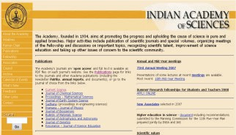

Type of Initiative: Open Access Journals

Principal Implementing Agency: Indian Academy of Sciences (IAS), Bangalore

Partner Institutions: Current Science Association, Bangalore; Indian Institute of Sciences, Bangalore; SpringerLink, Germany

Supporting Agency: Ministry of Science and Technology, Government of India Web Address 1: [www.ias.ac.in/pubs/journals/](http://www.ias.ac.in/pubs/journals)

Web Address [2: www.ias.ac.in/publications.html](http://www.ias.ac.in/publications.html)

##### Brief Description:

The Indian Academy of Sciences (IAS) is a scientific academy funded by the Government of India. It was established in 1934 and publishes 11 journals. All journals are open access and full-text literature is available as PDF files on each journal's website. All of the articles in current issues of these journals are born-digital. The articles of back volumes, which were not born-digital, have been digitized through a government-supported project. IAS has already archived all articles of journals from the first volume. From 2007 onwards, IAS journals are also available through SpringerLink, a subscription-based gateway of electronic journals. Table 8 provides a list of IAS published open access journal titles.

59

**Table 8: Indian Academy of Sciences Published Open Access Journals**



|  |  |  |  |
| --- | --- | --- | --- |
| **Sr.**  **No.** | **Journal Name** | **Web Address** | **Full** -**text Availability from Year and Volume Number** |
| 1 | Current Science | [www.ias.ac.in/currsci/](http://www.ias.ac.in/currsci) | 1932 (V.1) |
| 2 | Journal of Chemical Sciences | [www.ias.ac.in/chemsci/](http://www.ias.ac.in/chemsci) | 1977 (V.86) |
| 3 | Proceedings - Mathematical Sciences | [www.ias.ac.in/mathsci/](http://www.ias.ac.in/mathsci) | 1978 (V.87) |
| 4 | Journal of Earth System Science | [www.ias.ac.in/jess/](http://www.ias.ac.in/jess) | 1978 (V.87) |
| 5 | Sadhana (Proceedings in Engineering Sciences) | [www.ias.ac.in/sadhana/](http://www.ias.ac.in/sadhana) | 1978 (V.1) |
| 6 | Pramana- Journal of Physics | [www.ias.ac.in/pramana/](http://www.ias.ac.in/pramana) | 1973 (V.1) |
| 7 | Journal of Biosciences | [www.ias.ac.in/jbiosci/](http://www.ias.ac.in/jbiosci) | 1979 (V.1) |
| 8 | Bulletin of Materials Science | [www.ias.ac.in/matersci/](http://www.ias.ac.in/matersci) | 1979 (V.1) |
| 9 | Journal of Astrophysics and Astronomy | [www.ias.ac.in/jaa/](http://www.ias.ac.in/jaa) | 1980 (V.1) |
| 10 | Journal of Genetics | [www.ias.ac.in/jgenet/](http://www.ias.ac.in/jgenet) | 1999 (V.78) |
| 11 | Resonance - Journal of Science Education | [www.ias.ac.in/resonance/](http://www.ias.ac.in/resonance) | 1996 (V.1) |

### IndianJournals.Com Hosted Open Access Journals

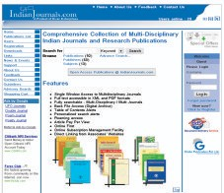

60

Type of Initiative: Open Access Journals



Principal Implementing Agency: Divan Enterprises, New Delhi

Partner Institutions: Academic and Professional Institutions/ Societies in India and other Asian countries

Web Address: [www.indianjournals.com](http://www.indianjournals.com/)

Allied Projects: GPMed Gateway to Current Medical Information [www.globepub.com/gpmed/](http://www.globepub.com/gpmed)

##### Brief Description:

IndianJournals.com provides single window access to multidisciplinary Indian journals published by different scholarly societies and institutions. It provides access to eleven open access journals and periodicals. This journal gateway also provides access to subscription-based content. These open access scholarly journals mainly belong to the science, technology and medicine (STM) areas. These journals are Open Archives Initiative (OAI)-compliant. This common journal gateway is freely accessible if the users register their names in the website. These journals are searchable from the main page of the gateway, which also maintains an archive of back volumes. Table 9 provides a list of IndianJournals.com hosted open access journal titles.

**Table 9: IndianJournals.com Hosted Open Access Journals**

|  |  |  |
| --- | --- | --- |
|  | Journal Name | Full-text Availability  from Year and Volume No. |
| 1 | Anil Aggrawals Internet Journal of Forensic Medicine and Toxicology | 2000 (v.1) |
| 2 | Fire Engineering | 2004 (v.29) |
| 3 | Indian Journal of Forensic Medicine & Toxicology | 2007 (v.1) |
| 4 | Indian Journal of Physiotherapy and Occupational Therapy | 2007 (v.1) |
| 5 | Indian Journal of Sleep Medicine | 2007 (v.1) |
| 6 | Journal of Bombay Veterinary College (The) | 2004 (v.12) |
| 7 | Journal of Neonatology | 2003 (v.17) |
| 8 | Journal of Research, SKUAST-J | 2005 (v.4) |
| 9 | Medico-Legal Update | 2006 (v.6) |
| 10 | Money and Finance | 2004 (v.2) |
| 11 | Vetline | 2006 (v.6) |

61

### Kamla-Raj Enterprises Published Open Access Journals



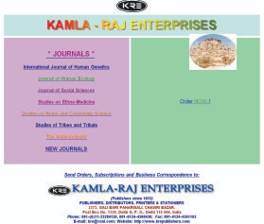

Type of Initiative: Open Access Journals

Principal Implementing Agency: Kamla-Raj Enterprises, Delhi

Partner Institutions: Academic Institutions and Scholarly Societies in India Web Address: [www.krepublishers.com/KRE-New-J/index.html](http://www.krepublishers.com/KRE-New-J/index.html)

##### Brief Description:

The Kamla-Raj Enterprises is a Delhi-based publisher established in 1933. Kamla-Raj publishes seven print-based peer-review scholarly journals mainly in the areas of social sciences which are also available in electronic format on open access. These journals are OAI-compliant. The publisher maintains an archive of each of these open access journals starting from volume one. Table 10 provides a list of Kamla-Raj published open access journal titles.

62

**Table 10: Kamla-Raj Enterprises Hosted Open Access Journals**

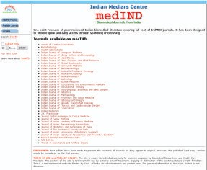

|  |  |  |
| --- | --- | --- |
| **Sr. No.** | **Journal Name** | **Full-text Availability from Year and Volume No.** |
| 1 | Anthropologist , The | 2003 (v.5) |
| 2 | International Journal of Human Genetics | 2001 (v.1) |
| 3 | Journal of Human Ecology | 2004 (v.15) |
| 4 | Journal of Social Sciences | 2004 (v.8) |
| 5 | Studies of Tribes and Tribals | 2003 (v.1) |
| 6 | Studies on Ethno -Medicine | 2007 (v.1) |
| 7 | Studies on Home and Community Science | 2007 (v.1) |

### MEDIND@NIC: Biomedical Journals from India

63

Type of Initiative: Open Access Journals



Principal Implementing Agency: Indian MEDLARS Centre (IMC), Bibliographic Informatics Division, National Informatics Centre (NIC), New Delhi

Supporting Agency: Indian Council of Medical Research (ICMR), Ministry of Health and Family Welfare, Government of India

Web Address: [http://medind.nic.in](http://medind.nic.in/) Allied Projects:

•IndMED@NIC [http://indmed.nic.in](http://indmed.nic.in/)

•OpenMED@NIC [http://openmed.nic.in](http://openmed.nic.in/)

•Union Catalogue of Biomedical Periodicals [http://uncat.nic.in](http://uncat.nic.in/)

##### Brief Description:

The Indian MEDLARS Centre at the National Informatics Centre has initiated two unique projects with support from the Indian Council of Medical Research. The first one is INDMED@NIC that indexes 70+ prominent biomedical journals of India from 1985 onwards. This INDMED bibliographic database is available online. Another project, MEDIND@NIC is an open access initiative from NIC that provides open access to the full-text content of 38 Indian biomedical journals. MEDIND@NIC aims at providing online access to full-text Indian biomedical periodicals to the users within and outside India. Different publishers, mainly learned societies in the respective specialized areas, publish these journals in print-on-paper format. Initially, MEDIND@NIC started digitization of the contents of back volumes of the journals. But now they are getting born-digital content of current issues from the publishers. Some of these publishers also provide full-text access separately from their own websites. The metadata of these journal articles are also maintained and searchable in the INDMED database. Current issues of all journals are available from this single gateway. Table 11 provides a list of INDMED@NIC hosted open access journal titles.

**Table 11: MEDIND@NIC Hosted Open Access Journals**

|  |  |  |
| --- | --- | --- |
| **Sr. No.** | **Journal Name** | **Full-text Availability from Year and Volume No.** |
| 1 | Annals of Cardiac Anaesthesia | 2005 (v.8) |
| 2 | Endodontology | 2000 (v.12) |
| 3 | Health Administrator | 2000 (v.9) |
| 4 | Indian Journal of Aerospace Medicine | 2000 (v.44) |
| 5 | Indian Journal of Allergy Asthma and Immunology | 2000 (v.14) |
| 6 | Indian Journal of Anaesthesia | 2002 (v.46) |
| 7 | Indian Journal of Chest Diseases and Allied Sciences | 2000 (v.42) |
| 8 | Indian Journal of Clinical Biochemistry | 2002 (v.17) |
| 9 | Indian Journal of Community Medicine | 2000 (v.25) |
| 10 | Indian Journal of Gastroenterology | 2004 (v.23) |

64



|  |  |  |
| --- | --- | --- |
| **Sr. No.** | **Journal Name** | **Full-text Availability**  **from Year and Volume No.** |
| 11 | Indian Journal of Medical and Paediatric Oncology | 2001 (v.22) |
| 12 | Indian Journal of Medical Microbiology | 2001 (v.19) |
| 13 | Indian Journal of Medical Research | 2004 (v.119) |
| 14 | Indian Journal of Nephrology | 2001 (v.11) |
| 15 | Indian Journal of Nuclear Medicine | 2002 (v.17) |
| 16 | Indian Journal of Occupational and Environmental Medicine | 2003 (v.7) |
| 17 | Indian Journal of Occupational Therapy | 2002 (v.33) |
| 18 | Indian Journal of Otolaryngology and Head and Neck Surgery | 2001 (v.53) |
| 19 | Indian Journal of Pediatrics | 2005 (v.72) |
| 20 | Indian Journal of Pharmacology | 2000 (v.32) |
| 21 | Indian Journal of Preventive and Social Medicine | 2003 (v.34) |
| 22 | Indian Journal of Radiology and Imaging | 2004 (v.14) |
| 23 | Indian Journal of Sexually Transmitted Diseases | 2004 (v.25) |
| 24 | Indian Journal of Thoracic and Cardiovascular Surgery | 2003 (v.19) |
| 25 | Indian Journal of Tuberculosis | 2000 (v.47) |
| 26 | Indian Pediatrics | 2004 (v.41) |
| 27 | J.K. Practitioner | 2001 (v.8) |
| 28 | Journal, Indian Academy of Clinical Medicine | 2000 (v.5) |
| 29 | Journal of Family Welfare | 2000 (v.46) |
| 30 | Journal of Indian Academy of Forensic Medicine | 2004 (v.26) |
| 31 | Journal of Indian Rheumatology Association | 2002 (v.10) |
| 32 | Journal of Obstetrics and Gynecology of India | 2004 (v.54) |
| 33 | Journal of the Anatomical Society of India | 2001 (v.50) |
| 34 | Journal of Indian Association of Pediatrics Surgeons | 2001 (v.6) |
| 35 | Journal of Indian Society of Pedodontics and Preventive Dentistry | 2000 (v.18) |
| 36 | Medical Journal Armed Forces India | 2000 (v.56) |
| 37 | NTI Bulletin | 2000 (v.36) |
| 38 | Trends in Biomaterials and Artificial Organs | 2001 (v.15) |

65

### Medknow Publications Hosted Open Access Journals



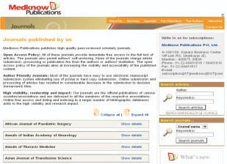

Type of Initiative: Open Access Journals

Principal Implementing Agency: Medknow Publications Private Limited, Mumbai

Partner Institutions: Bio-medical Institutions and Scientific Societies in India and other Asian Countries

Web Address: [www.medknow.com/journals.asp](http://www.medknow.com/journals.asp)

Allied Projects: *Journal- on-Web*: Web-based Manuscript Submission and Peer Review <http://www.journalonweb.com/>

##### Brief Description:

Medknow Publications Private Limited is a publisher of high-quality peer-reviewed scholarly open access journals in India. Medknow publishes, maintains and hosts 48+ peer-reviewed scholarly journals, mainly in the biomedical subject areas. Medknow also provides solutions to the scientific societies and scholarly institutions, through *Journal-on-Web* a web-based manuscript submission and peer review system that handles pre-publication and post- publication processes for journal issues. Medknow collaboratively publishes the electronic versions of some existing journals of learned societies and institutions in India. These journals

66

also accept online submission of manuscripts through dedicated websites for respective journals. These journals are OAI-compliant. Metadata harvesters, search engines and indexing services index and harvest metadata of the current issues of the journals from the individual journal websites. Table 12 provides a list of Medknow hosted open access journal titles.



**Table 12: Medknow Publications Hosted Open Access Journals**

|  |  |  |
| --- | --- | --- |
| **Sr. No.** | **Journal Name** | **Full-text Availability from Year and Volume No.** |
| 1 | African Journal of Paediatric Surgery | 2007 (v.4) |
| 2 | Annals of Indian Academy of Neurology | 2006 (v.9) |
| 3 | Annals of Thoracic Medicine | 2006 (v.1) |
| 4 | Asian Journal of Transfusion Science | 2007 (v.1) |
| 5 | Hepatitis B Annual | 2004 (v.1) |
| 6 | Indian Journal of Cancer | 2003 (v.39) |
| 7 | Indian Journal of Community Medicine | 2007 (v.32) |
| 8 | Indian Journal of Critical Care Medicine | 2003 (v.7) |
| 9 | Indian Journal of Dental Research | 2006 (v.17) |
| 10 | Indian Journal of Dermatology | 2005 (v.50) |
| 11 | Indian Journal of Dermatology, Venereology, and Leprology | 2001 (v.56) |
| 12 | Indian Journal of Human Genetics | 2002 (v.8) |
| 13 | Indian Journal of Medical Microbiology | 2001(v.19) |
| 14 | Indian Journal of Medical Sciences | 2001 (v.55) |
| 15 | Indian Journal of Nephrology | 2007 (v. 17) |
| 16 | Indian Journal of Occupational and Environmental Medicine | 2003 (v.7) |
| 17 | Indian Journal of Ophthalmology | 1975 (v.23) |
| 18 | Indian Journal of Orthopaedics | 2007 (v.41) |
| 19 | Indian Journal of Palliative Care | 2004 (v.9) |
| 20 | Indian Journal of Pharmaceutical Sciences | 2006 (v.68) |
| 21 | Indian Journal of Pharmacology | 1969 (v.1) |
| 22 | Indian Journal of Plastic Surgery | 2001 (v.34) |
| 23 | Indian Journal of Psychiatry | 2005 (v.47) |
| 24 | Indian Journal of Radiology and Imaging | 1999 (v.9) |
| 26 | Indian Journal of Sexually Transmitted Diseases | 2007 (v. 28) |
| 25 | Indian Journal of Surgery | 2003 (v.65) |
| 27 | Indian Journal of Urology | 2005 (v.21) |
| 28 | International Journal of Diabetes in Developing Countries | 2001 (v.21) |
| 29 | International Journal of Shoulder Surgery | 2007 (v.1) |
| 30 | International Journal of Yoga | 2007 (v.1) |
| 31 | Journal of Cancer Research and Therapeutics | 2005 (v.1) |
| 32 | Journal of Gynecological Endoscopy and Surgery | 2008 (v.1) |
| 33 | Journal of Human Reproductive Sciences | 2008 (v.1) |
| 34 | Journal of Indian Association of Pediatric Surgeons | 2005 (v.10) |
| 35 | Journal of Indian Society of Pedodontics and Preventive  Dentistry | 2005 (v.23) |

67

|  |  |  |
| --- | --- | --- |
| **Sr. No.** | **Journal Name** | **Full-text Availability from Year and Volume No.** |
| 36 | Journal of Medical Physics | 2006 (v.31) |
| 37 | Journal of Minimal Access Surgery | 2005 (v.1) |
| 38 | Journal of Oral and Maxillofacial Pathology | 2007 (v.11) |
| 40 | Journal of Pediatric Neurosciences | 2006 (v.1) |
| 41 | Journal of Postgraduate Medicine | 1980 (v.26) |
| 42 | Journal of Sexual Medicine, Andrology and Gender | 2008 (v.1) |
| 43 | Medical Law Cases for Doctors | 2008 (v.1) |
| 44 | Mens Sana Monographs | 2003 (v.1) |
| 45 | Neurology India | 1999 (v.47) |
| 46 | Noise and Health | 1998 (v.1) |
| 47 | Saudi Journal of Gastroenterology | 2006 (v.12) |
| 48 | The Journal of Indian Prosthodontic Society | 2005 (v.5) |



68



# METADATA HARVESTING SERVICES

69

### Cross Archive Search Service for Indian Repositories (CASSIR)



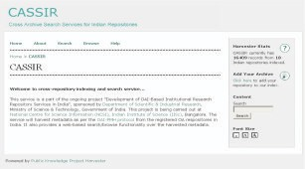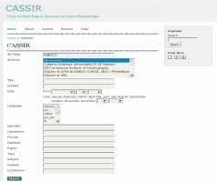

Figure 11: Comprehensive Search Facility at CASSIR

70

Type of Initiative: Metadata Harvesting Service



Principal Implementing Agency: National Centre for Science Information (NCSI), Indian Institute of Science (IISc), Bangalore

Supporting Agency: Department of Scientific and Industrial Research (DSIR), Ministry of Science and Technology, Government of India

Software Used: Public Knowledge Project (PKP) Harvester Web Address 1: [http://casin.ncsi.iisc.ernet.in/oai/](http://casin.ncsi.iisc.ernet.in/oai)

Web Address 2: [http://ardb4.ncsi.iisc.ernet.in/oai/](http://ardb4.ncsi.iisc.ernet.in/oai)

Allied Projects:

•Electronic Theses and Dissertations of Indian Institute of Science <http://etd.ncsi.iisc.ernet.in/>

•EPrints @ IISc <http://eprints.iisc.ernet.in/>

•[PRABHAVI: Indian Institute of Science Publications Database http://vidya-](http://vidya-mapak.ncsi.iisc.ernet.in/cgi-bin/library) [mapak.ncsi.iisc.ernet.in/cgi-bin/library](http://vidya-mapak.ncsi.iisc.ernet.in/cgi-bin/library)

•Sci-Gate: The IISc Science Information Portal <http://www.ncsi.iisc.ernet.in/>

•Scientific Journal Publishing in India: Indexing and Online Management <http://sjpi.ncsi.iisc.ernet.in/>

•LIS-Forum - Discussion Forum for Library and Information Professionals in India <http://ncsi.iisc.ernet.in/mailman/listinfo/lis-forum>

•KM-Forum - Global Discussion Forum for Knowledge Management <http://ncsi.iisc.ernet.in/mailman/listinfo/km-forum>

##### Brief Description:

The CASSIR is a metadata harvesting service for Indian repositories, a project initiated by the National Centre for Science Information (NCSI) of the Indian Institute of Science (IISc) and supported by DSIR. This web-based search and browse service is a part of the ongoing project entitled 'Development of OAI-Based Institutional Research Repository Services in India'. In this service, *Open Archives Initiative-Protocol for Metadata Harvesting* (OAI-PMH) compliant software (PKP Harvester) harvests metadata from the registered open access repositories in India. At present, CASSIR covers eighteen Indian open access repositories:

•Catalysis Database (ePrints@NCCR IIT Madras)

•DRS at National Institute of Oceanography

•DSpace at ICFAI BUSINESS SCHOOL (IBS), Ahmedabad

•DSpace at IIMK

•DSpace at National Chemical Laboratory, Pune, India

•DSpace at Vidyanidhi

•DSpace@DRTC

•Dspace@NITR

•DU Eprint Archive

71

•ePrints@IISc



•ePrints@IIT Delhi

•ETD @ Indian Institute of Science

•Indian Institute of Astrophysics

•DSpace at ISI Library, Bangalore

•NAL Institutional Repository

•OneWorld South Asia Open Archive Initiative

•OpenMED@NIC

•RRI Digital Repository

These open access repositories store a number of scholarly publications in digital format. Thus, CASSIR serves a functionality of cross-searching of repositories. This cross-searching functionality is much needed in a country like India where hundreds of open access repositories are expected to be proliferated in near future, if the *UGC (Submission of Metadata and Full-text of Doctoral Theses in Electronic Format) Regulations* implemented soon. Figure 11 shows the search interface of CASSIR, where searching of scholarly publications in Indian repositories can be carried out easily, by limiting document type such as 'thesis'.

### Open Index Initiative

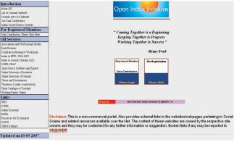

72

Type of Initiative: Metadata Harvesting Service



Principal Implementing Agency: Indira Gandhi Institute of Development Research (IGIDR) Library, Mumbai

Supporting Agency: Indira Gandhi Institute of Development Research (IGIDR), Reserve Bank of India, Government of India

Web Address: [http://oii.igidr.ac.in](http://oii.igidr.ac.in/)

Allied Project: IGIDR Working Papers Online <http://www.igidr.ac.in/lib/papers.php>

##### Brief Description:

The Open Index Initiative (OII) is a collaborative effort of 16+ volunteers working in Indian social science libraries across 5+ Indian cities, with a basic objective to develop an exhaustive online database with index and abstract to journal articles, book reviews, conference papers, and working papers published in Indian social science journals or published by Indian social science institutions. The Open Index Initiative (OII) portal facilitates information on:

•Forthcoming Conferences/Seminars/Workshops in India in Social Sciences and related areas

•Indian Social Science Associations and Professional Bodies

•Search for Book Reviews

•Index to Articles of *Economic and Political Weekly* (EPW, 19922005)

•Index to Journal Articles

•Open Source Software and Experts

•Online Directory of Social Science Institutions

•Theses and Dissertations

•Union Catalogue of Journals

•Working Papers Online

•IGIDR OPAC (Online Public Access Catalogue)

The volunteers in this initiative contribute their data on the scholarly resources available with them. The web-based data entry module facilitates recording of data, related to:

•Experts in Open Source Software

•Index to Journal Contents

•Update the Online Directory of Libraries

•Statistical and Government Publications

•Theses and Dissertations

•Union Catalogue of Journals

•Working Papers

OII is a public-access database that promotes scholarly literature in social sciences, produced by Indian social science researchers/institutions or published in Indian social science journals. It

73

follows the human-driven metadata submission model, in contrast to the software-driven metadata extraction model. Thus, the OII system gets a wide variety of data sets, which is unparallel to the metadata harvesting services established elsewhere.



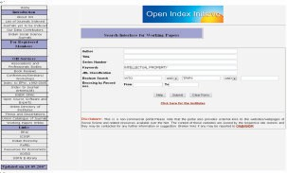

Figure 12: OII Search Interface for Working Papers

### Open J-Gate



74

Type of Initiative: Open Access Journal Gateway



Principal Implementing Agency: Informatics India Limited, Bangalore Partner Institutions: Publishers of Open Access Journals

Web Address: [www.openj-gate.com](http://www.openj-gate.com/)

Allied Projects:

•J-Gate <http://j-gate.informindia.co.in/>

•J-Gate Custom Content (JCC)

•J-Gate Custom Content for Consortia (JCCC) <http://www.jccc-indest.informindia.co.in/>, [http://www.jccc-icmr.informindia.co.in](http://www.jccc-icmr.informindia.co.in/)

##### Brief Description:

On February 27, 2006, Informatics India Limited launched *Open J-Gate*, a searchable portal of open-access journals that provides access to 4,300+ open access journals and million plus records of articles. Open J-Gate is the first corporate initiative in India to promote and support open access initiatives. The bibliographic database is maintained in a well-index database, having the metadata such as, the title of the article, name of authors, author email-id, author's affiliation, source, keywords, abstract and full-text links to each article. It has Quick Search, Advanced Search, and Browse by journal options. In Advanced Search option, search can be limited to a few subject categories or sub-categories, journal type, a few metadata (such as title, keyword, abstract, author, institution/address, or, all). When search results are displayed, each retrieved record provides details of the article and links to full-text article at publisher sites. In this service, full-text links are regularly validated.

Open J-Gate follows three-level hierarchical system, where first consists of seven main subject categories, such as:

•Agricultural and Biological Sciences

•Arts and Humanities

•Basic Sciences

•Biomedical Sciences

•Engineering and Technology

•Library and Information Sciences

•Social and Management Sciences

Open J-Gate covers open access peer-reviewed journals as well as professional and industry journals. Although this service has worldwide coverage, mainly open access journals published in English language are indexed in this online database.

75

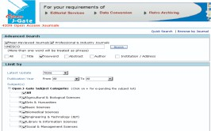



Figure 13: Open J-Gate Advance Search Interface

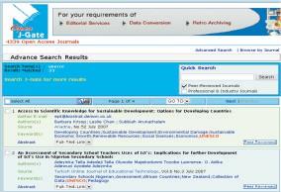

Figure 14: Open J-Gate Advance Search Results

76

### Scientific Journal Publishing in India: Indexing and Online Management (SJPI)

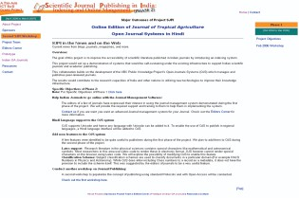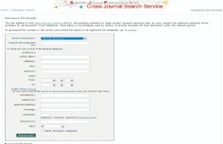

Figure 15: Cross Journals Search Facility at SJPI

77

Type of Initiative: Metadata Harvesting Service



Principal Implementing Agency: National Centre for Science Information (NCSI), Indian Institute of Science (IISc), Bangalore

Supporting Agencies: Pan Asia Networking, IDRC, Canada; Asian Media and Information Centre (AMIC), Singapore; Asia-Pacific Development Information Programme (APDIP.net), UNDP; Internet Society, USA; Asia Pacific Network Information Centre (APNIC), Australia

Software Used: Public Knowledge Project (PKP) Harvester; PKP Open Journals Systems (OJS) Web Address 1: <http://sjpi.ncsi.iisc.ernet.in/>

Web Address 2: [http://sjpi.ncsi.iisc.ernet.in/harvester/](http://sjpi.ncsi.iisc.ernet.in/harvester)

Allied Projects:

•Electronic Theses and Dissertations of Indian Institute of Science <http://etd.ncsi.iisc.ernet.in/>

•EPrints @ IISc <http://eprints.iisc.ernet.in/>

•PRABHAVI: Indian Institute of Science Publications Database <http://vidya-mapak.ncsi.iisc.ernet.in/cgi-bin/library>

•Sci-Gate: The IISc Science Information Portal <http://www.ncsi.iisc.ernet.in/>

•Cross Archive Search Service for Indian Repositories (CASSIR) [http://casin.ncsi.iisc.ernet.in/oai/](http://casin.ncsi.iisc.ernet.in/oai)

•LIS-Forum - Discussion Forum for Library and Information Professionals in India <http://ncsi.iisc.ernet.in/mailman/listinfo/lis-forum>

•KM-Forum - Global Discussion Forum for Knowledge Management <http://ncsi.iisc.ernet.in/mailman/listinfo/km-forum>

##### Brief Description:

The Scientific Journal Publishing in India (SJPI) is a project funded by international development agencies, having as project goal to improve the accessibility of scientific literature published in Indian journals by introducing an indexing system. This is a kind of demonstration of a system that would be self-sustaining under the existing infrastructure to support Indian scientific journals and academic publishing. The project popularizes to editors and administrators of Indian scientific journals and academic publishing, a free and open source software (FOSS), named Open Journals Systems (OJS) developed by UBC Public Knowledge Project. OJS assists with every stage of the refereed publishing process, from submissions to online publication and indexing. Additionally, OJS helps OAI-PMH compliant metadata harvesters to index/harvest the contents of open access journal issues. The SJPI is implemented in two phases, where each phase has some specific objectives, which are given in Table 13.

78

Table 13: Specific Objectives of SJPI Project



##### Specific Objectives of Phase 1

•The indexing module would be demonstrated with the Indian Academy of Sciences journals ([http://www](http://www/)[.ias.ac.in/).](http://www.ias.ac.in/)

•The complete management system would be implemented with the Journal of Indian Institute of Science ([http://journal.library.iisc.ernet.in/).](http://journal.library.iisc.ernet.in/)

•The technical team of the Public Knowledge Project would consult the researchers at NCSI to ensure the design improvements contribute to OJS and related systems.

•The metadata generated by the demonstration journals would be harvested at the National Centre for Science Information using the Public Knowledge Project's open source PKP Harvester. This would establish an indexing portal for Indian online scholarly publications that would complement NCSI's well-established 'SciGate: The IISc Science Information Portal' and the 'IISc EPrints Archive'.

•The metadata collected by NCSI's PKP Harvester would be harvested, in turn, by the global engines, such as OAIster, creating a global presence for Indian research journals.

•This will also enable exploration of establishing linkages with other international efforts like the Directory of Open Access Journals (DOAJ) of the Open Society Institute and contribution to global efforts in open access to research literature.

##### Specific Objectives of Phase 2

•To help Indian Journals to go online with the Journal Management Software

•To support Hindi language to the OJS system

•To add new features to the OJS system, e.g. Latex support, Classification Scheme

•To conduct another workshop on Open Access Journal Publishing

In the first phase, a Prototype Journal System was set up using OJS software, where the following journals participated:

•Bulletin of Materials Science

•Current Science

•Journal of Astrophysics and Astronomy

•Journal of Biosciences

•Journal of Chemical Sciences

•Journal of Genetics

•Journal of Indian Institute of Science

•Pramana: Journal of Physics

•Proceedings - Earth and Planetary Sciences

•Proceedings - Mathematical Sciences

•Resonance - Journal of Science Education

79

•Sadhana (proceedings in engineering sciences)



•SRELS Journal of Information Management (SJIM)

The SJPI Cross Journals Search Service is part of the SJPI project. In this service, an OAI-PMH compliant software (PKP Harvester) harvests metadata from the sample full-text contents of participating Indian scholarly journals. This demonstrates a single point search service across multiple scholarly journals. The SJPI Cross Journals Search Service covers Indian journals listed above. Although this SJPI Cross Journals Search Service is a prototype system and not updated regularly, this is still available online.

### Search Digital Libraries (SDL)

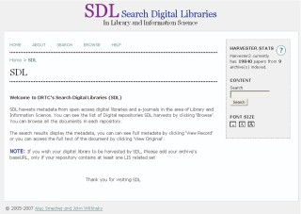

80

Type of Initiative: Metadata Harvesting Service



Principal Implementing Agency: Documentation Research and Training Centre (DRTC), Indian Statistical Institute, Bangalore

Supporting Agency: Indian Statistical Institute, Government of India Software Used: Public Knowledge Project (PKP) Harvester

Web Address: [http://drtc.isibang.ac.in/sdl/](http://drtc.isibang.ac.in/sdl)

Allied Projects:

•Librarians' Digital Library <https://drtc.isibang.ac.in/>

•Indo-German eGurukul on Digital Libraries [http://drtc.isibang.ac.in/mmb/](http://drtc.isibang.ac.in/mmb)

•DLRG - Digital Library Research Group (a Discussion Forum) <http://drtc.isibang.ac.in/mailman/listinfo/dlrg>

•Sankhya, the Indian Journal of Statistics (an Open Access Journal) <http://sankhya.isical.ac.in/>

##### Brief Description:

The Search Digital Libraries (SDL) is a metadata harvesting service for open access repositories in the area of library and information science, a project initiated by the Documentation Research and Training Centre (DRTC) of the Indian Statistical Institute (ISI Bangalore). In this service, an OAI- PMH compliant software (PKP Harvester) harvests metadata from the registered open access repositories in the subject area of library and information science. At present, SDL covers nine open access repositories, including one from India:

•Australian Library and Information Association e-prints

•CALTECHLIB

•CCSD: Sciences de l'Information et de la Communication, France

•DLIST, University of Arizona

•E-LIS: E-Prints in Library and Information Science

•Journal of Technology Management & Innovation

•Librarians' Digital Library (LDL)

•OCLC Research Publications

•University of North Carolina, USA

These open access repositories store a number of scholarly publications in digital format. Thus, SDL serves a functionality of cross-searching subject-specific repositories. Figure 16 shows the Browse interface of SDL, where browsing of scholarly publications in a selected repository can be carried out easily, followed by retrieval of relevant document.

81

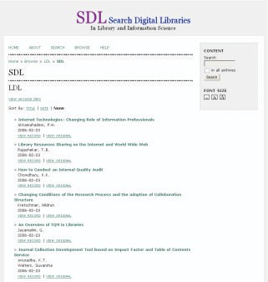



Figure 16: Browse by the Open Access Archive at SDL

82



# NATIONAL LEVEL OPEN ACCESS REPOSITORIES

83

### Catalysis Database



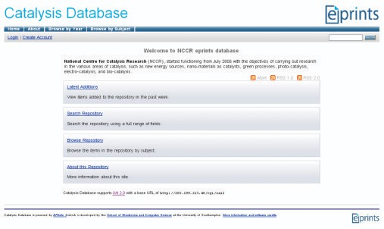

Type of Initiative: Institutional Repository

Principal Implementing Agency: National Centre for Catalysis Research (NCCR), Indian Institute of Technology Madras (IITM), Chennai

Participating Institution: Catalysis Society of India

Supporting Agency (Indian): Indian Institute of Technology Madras (IITM), Ministry of Human Resource Development, Government of India

Software Used: EPrints

Web Address: [www.eprints.iitm.ac.in](http://www.eprints.iitm.ac.in/)

##### Brief Description:

The National Centre for Catalysis Research (NCCR) is a premier research institution devoted to interdisciplinary research in catalysis, chemical sciences and allied areas. The Catalysis Database collects, preserves and disseminates the scholarly materials in digital format produced by members of the Catalysis Society of India (CSI) and/or the scientists of the National Centre for Catalysis

84

Research (NCCR). This database contains research publications, conference papers, conference proceedings, theses and dissertations related to a narrower area of chemical sciences that covers the various areas of catalysis, namely, new energy sources, nano-materials, catalysts, green processes, photo-catalysis, electro-catalysis, and bio-catalysis. This portal provides RSS and Atom feeds for keeping readers up to date with new additions. This repository is compliant to OAI-PMH (Protocol for Metadata Harvesting) and indexed in the CASSIR (Cross Archive Search Service for Indian Repositories), OAIster and OpenDOAR (Directory of Open Access Repositories).

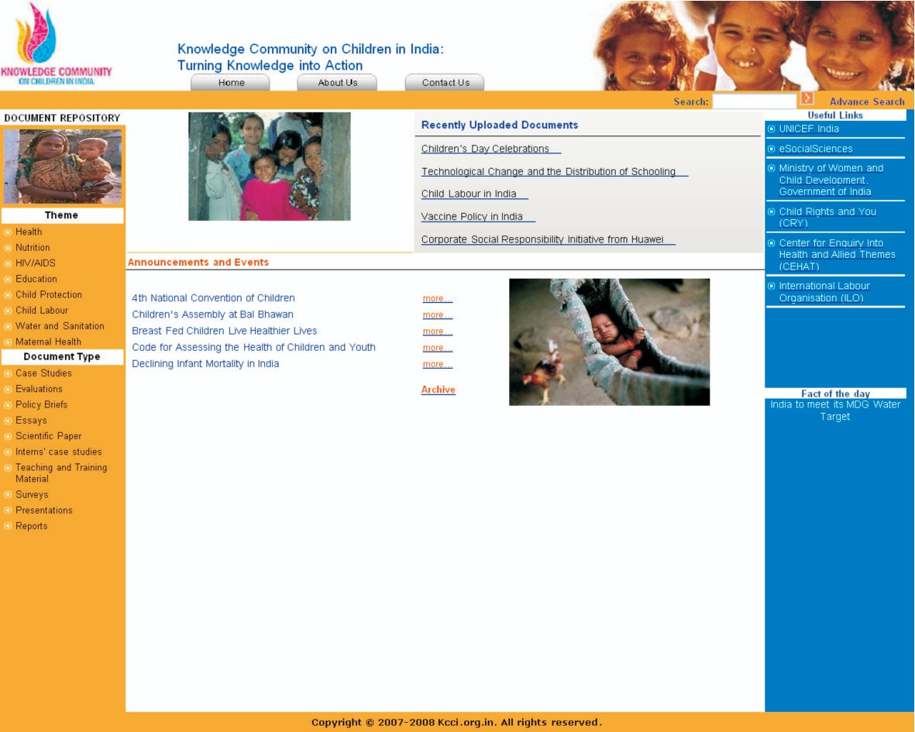

### Knowledge Community on Children in India: Turning Knowledge into Action

85

Type of Initiative: Digital Repository



Principal Implementing Institutions: eSocialSciences, Mumbai (Content Management); Strategic Planning, Monitoring and Evaluation Unit, UNICEF, New Delhi

Participating Institutions: Ministry of Women and Child Development, Government of India; Child Rights and You (CRY); Center for Enquiry into Health and Allied Themes (CEHAT) and the International Labour Organisation (ILO)

Supporting Agency: United Nations Children's Fund (UNICEF), India Web Address: <http://www.kcci.org.in/>

Allied Project: eSocialSciences <http://www.esocialsciences.com/>

##### Brief Description:

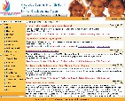The *Knowledge Community on Children in India* (KCCI) is a digital archiving initiative supported by UNICEF India for widening the knowledge base in the sectoral areas. The KCCI project aims at promoting information-sharing on policies and programmes related to children in India. The KCCI portal aims to be a dynamic, up to date repository of evidence-based research in the form of case studies, research papers, articles on policies and programmes related to the development of women and children. This portal is also filling the knowledge gaps in the implementation of successful intervention programmes for children. The case studies of successful projects answer the basic questions of “what works?” and “what could be improved?”. The KCCI initiative helps in gathering lessons from the field in order to improve programming and eventually influence policies related to children. The eSocialSciences (eSS), a broad-based, multidisciplinary social sciences and humanities portal, is the content development partner that coordinates archiving of relevant documents from UNICEF partner organizations. This open access document repository makes available case studies, evaluations, policy briefs, essays, scientific papers, interns' case studies, teaching and training materials, surveys, presentations and reports. This portal has different subject categories linked to children such as health, nutrition, HIV/AIDS, education, child protection, child labour, water and sanitation and maternal health. It is also endowed with simple as well as advanced search facilities to retrieve the documents archived therein.

Figure 17: Documents Displayed in the Knowledge Community on Children in India

86

### Librarians' Digital Library (LDL)

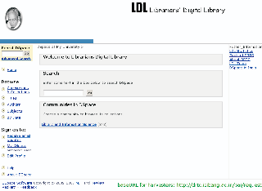

Type of Initiative: Open Access Archive

Principal Implementing Agency: Documentation Research and Training Centre (DRTC), Indian Statistical Institute, Bangalore

Supporting Agency: Indian Statistical Institute, Government of India Software Used: DSpace

Web Address: <https://drtc.isibang.ac.in/>

Allied Projects:

•Search Digital Libraries <http://drtc.isibang.ac.in/sdl>

•Indo-German eGurukul on Digital Libraries [http://drtc.isibang.ac.in/mmb/](http://drtc.isibang.ac.in/mmb)

•DLRG - Digital Library Research Group (a Discussion Forum) <http://drtc.isibang.ac.in/mailman/listinfo/dlrg>

•Sankhya, the Indian Journal of Statistics (an Open Access Journal) <http://sankhya.isical.ac.in/>

87

##### Brief Description:



The Documentation Research and Training Centre (DRTC) is a premier library school in India. DRTC conducts workshops and seminars annually on the latest topics applicable to the library and information services. The Librarians' Digital Library (LDL) is a national-level open access archive in the area of library and information science. Initially the collection was developed through a digitization project, where proceedings and training modules of DRTC seminars/workshops were digitized. Later, a self-archiving process was made open to the library professionals registered with this portal. This open access repository stores different kinds of scholarly materials such as journal articles, conference papers, theses, dissertations, reports, presentations, multimedia objects and digital photos pertaining to the specific subject. Although major documents are written in the English language, a few sample documents can be found in Hindi or Kannada. A certain level of encryption and security is embedded in the site which may cause some users accessibility problems. LDL also provides an indicative list of open access repositories in India using DSpace open source software. LDL has the potential to become an internationally-acclaimed open access repository similar to E-LIS (E-Prints in Library and Information Science) and dLIST (Digital Library of Library and Information Technology). This repository is compliant to OAI-PMH (Protocol for Metadata Harvesting) and indexed in the OpenDOAR (Directory of Open Access Repositories), Google Scholar and OAIster.

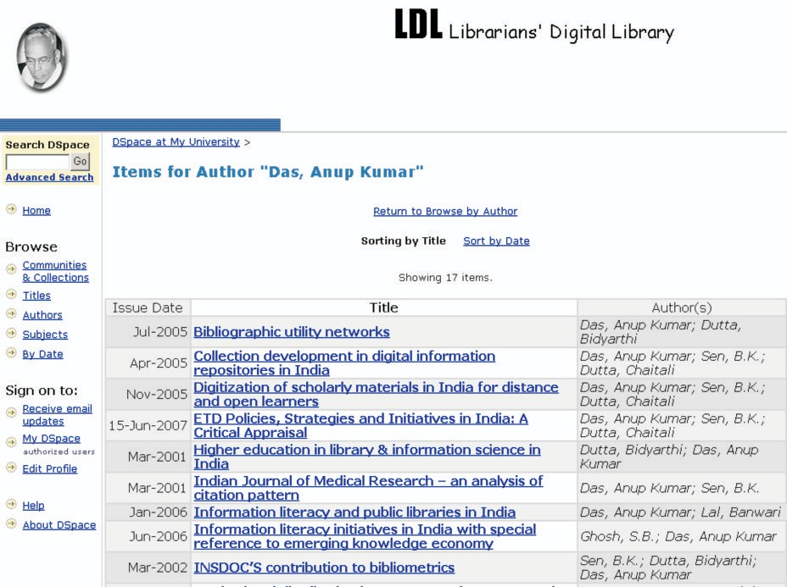

Figure 18: Navigating Content of LDL by Author

88

### OpenMED@NIC

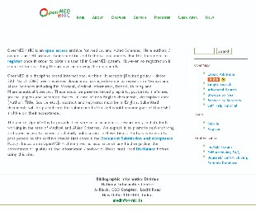

Type of Initiative: Open Access Archive

Principal Implementing Agency: Bibliographic Informatics Division, National Informatics Centre (NIC), New Delhi

Supporting Agency: National Informatics Centre, Ministry of Communication and Information Technology, Government of India

Software Used: EPrints

Web Address: <http://openmed.nic.in/>

Allied Projects: IndMED@NIC [http://indmed.nic.in](http://indmed.nic.in/) , MEDind@NIC <http://medind.nic.in/>, Union Catalogue of Biomedical Periodicals <http://uncat.nic.in/>

89

##### Brief Description:



The OpenMED is a national level open access archive for biomedical and allied sciences providing a self-archiving facility to biomedical researchers, practitioners and professionals. The objective of this initiative is to encourage a self-archiving culture amongst biomedical researchers, practitioners and professionals in India so that cases in evidence-based clinical practices and biomedical research reports can be widely disseminated. The goal of this repository is to preserve valuable research publications for future biomedical researchers and publicize research being conducted in the country. Although this repository has wide coverage in all major biomedical subject areas, it has a comprehensive collection of papers on tuberculosis as well as tropical diseases.

Using this facility, authors/researchers/practitioners can self-archive their scientific and technical documents. They would need to register once in order to obtain a unique user identity in the system. No registration is however required for searching the archive or viewing the documents. OpenMED accepts both published and unpublished documents having relevance to research in biomedical and allied sciences including paramedical areas. Self-archived contributions can be in the form of journal articles, conference papers, conference proceedings, posters, presentations, clinical cases, technical reports, working papers, policy documents, theses and dissertations. This repository also accepts documents in Indian languages, but in this case descriptive metadata is entered in English. The self-archived document then goes to the moderator and becomes part of the OpenMED archive on its acceptance. Presently, this archive also serves as a knowledge repository of journals, institutions and conference organizers in India for long-term preservation of research publications. These include:

•Institutional Repositories

➢College of Veterinary Science and Animal Husbandry, Anand Agricultural University

➢National Tuberculosis Institute

➢Sir Ganga Ram Hospital, New Delhi

•Journal Repositories

➢Anatolian Journal of Psychiatry

➢Archives of Medical Science

➢Calicut Medical Journal

➢Indian Journal of Medical Informatics

➢Indian Journal of Tuberculosis

➢Indian Pacing and Electrophysiology Journal

➢Indian Veterinary Journal

➢JK Science

➢Journal of Applied Basic Medical Sciences

➢Journal of Indian Association for Child and Adolescent Mental Health

➢Online Journal of Health and Allied Sciences

This repository is compliant to OAI-PMH (Protocol for Metadata Harvesting) and indexed in the CASSIR (Cross Archive Search Service for Indian Repositories), Google Scholar, OAIster and OpenDOAR (Directory of Open Access Repositories).

90

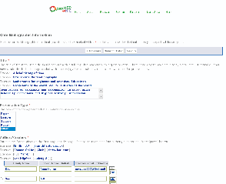



Figure 19: Creation of Metadata during Self-Archiving Process in OpenMED@NIC

### Pakistan Research Repository (PRR)

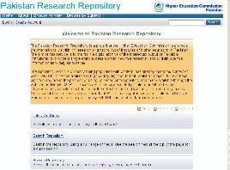

91

Type of Initiative: National Open Access Repository



Principal Implementing Agency: Higher Education Commission, Government of Pakistan Supporting Agency: Higher Education Commission, Government of Pakistan

Participating Institutions: Public Sector Universities, Private Sector Universities, and Degree Awarding Research Institutes

Software Used: EPrints

Web Address: [www.eprints.hec.gov.pk](http://www.eprints.hec.gov.pk/)

Related Project: HEC-National Digital Library [http://www.digitallibrary.edu.pk](http://www.digitallibrary.edu.pk/)

##### Brief Description:

The Higher Education Commission (HEC) is an apex body for higher education system in Pakistan that makes transformation of indigenous university system in Pakistan into a world class centre of education, research and development. The Pakistan Research Repository (PRR) is an open access digital archiving project of the Higher Education Commission to increase international visibility of results of research emanating from institutions of higher education in Pakistan. The aims of this service are to maintain a digital repository of the intellectual outputs of Pakistani institutions, to provide a single-entry access point to view this research, and to disseminate the scholarly literature as widely as possible. It provides Atom and RSS feeds for information registered users on latest additions. PRR can be browsed by type of documents. Presently it has archived journal articles, conference papers and PhD/MPhil theses and dissertations. Some other types of scholarly documents such as patents, monographs, books and learning resources will be added in near future. PRR has adopted a systematic mechanism for collection and digitization of MPhil and PhD level theses submitted in Pakistani universities. The present collection of electronic theses has following subject coverage:

•Agriculture and Veterinary Sciences

•Arts and Humanities

•Biological and Medical Sciences

•Business Administration and Management

•Engineering and Technology

•Physical Sciences

•Social Sciences

This repository is compliant to OAI-PMH (Protocol for Metadata Harvesting) and indexed in the OpenDOAR (Directory of Open Access Repositories), Google Scholar and OAIster.

92

### Urban Health Gateway



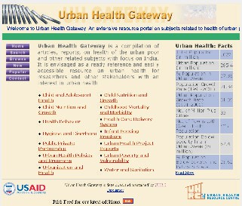

Type of Initiative: Subject Gateway

Principal Implementing Agency: Urban Health Resource Centre (UHRC), New Delhi Supporting Agency (Overseas): United States Agency for International Development (USAID) Software Used: WebBiblio Subject Gateway System (WebBiblio 3.0)

Web Address 1: [http://uhrc.in/uhgateway/](http://uhrc.in/uhgateway)

Web Address [2: http://uhrc.in/uhgateway/home/index.php](http://uhrc.in/uhgateway/home/index.php)

Related Project: WebBiblio Subject Gateway System <http://webbiblio.sourceforge.net/>

93

##### Brief Description:



Urban Health Gateway is an extensive collection of open access literature on health of the urban poor and other related subjects with focus on India. This is an initiative of Urban Health Resource Centre in New Delhi. This gateway is basically a compilation of articles, reports, and case studies on the specific subject areas. It is envisaged as a ready reference and easily accessible resource on urban health for researchers and other stakeholders with an interest in urban health. This initiative strives to improve access to the public healthcare system in urban, semi-urban and industrial areas, where access to relevant information at the right time is very crucial. This gateway helps to find urban health-related information and leads researchers to the point where the resources are available. This portal provides RSS Feeds for informing latest additions to the registered users. This gateway covers the following areas in biomedical sciences:

•Child and Adolescent Health

•Child Nutrition and Growth

•Childhood Mortality and Morbidity

•Health Behaviour

•Health Care Delivery System

•Hygiene and Diarrhoea

•Infant Feeding Practices

•Public Private Partnership

•Urban Health Project Reports

•Urban Health Policies and Programmes

•Urban Poverty and Vulnerability

•Urbanization and Health

•Water and Sanitation

This Gateway runs on WebBiblio, an open source subject gateway system, developed by an Indian called Jack Eapen. It provides user-friendly searching and browsing facilities. Most popular titles and latest additions are also found in this portal.

94

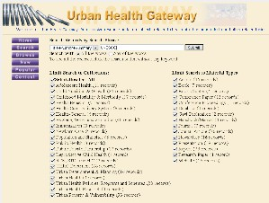



Figure 20: Urban Health Gateway Search Interface

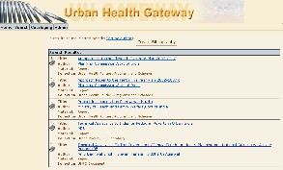

Figure 21: Urban Health Gateway Search Result

95



**INSTITUTIONAL REPOSITORIES**

96

### Digital Archive of National Institute of Technology - Rourkela



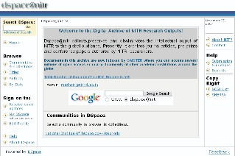

Type of Initiative: Institutional Repository

Principal Implementing Agency: National Institute of Technology- Rourkela (NITR)

Supporting Agency: National Institute of Technology- Rourkela, Ministry of Human Resource Development, Government of India

Software Used: DSpace

Web Address: [http://dspace.nitrkl.ac.in/dspace/](http://dspace.nitrkl.ac.in/dspace)

##### Brief Description:

The National Institute of Technology Rourkela, one of the National Institutes of Technology spread all over the country, is engaged in higher education and research activities in the areas of engineering, technologies and applied sciences. The NITR institutional repository collects, preserves and disseminates intellectual outputs of the host institution to the global audience. At present, it archives conference papers, journal articles, preprints and theses authored by NITR researchers and faculty members. Registered users of the portal can get email alerts on regular intervals to notify them of newly added relevant contents. This repository is compliant to OAI-PMH (Protocol for Metadata Harvesting) and indexed in the CASSIR (Cross Archive Search Service for Indian Repositories), OAIster and OpenDOAR (Directory of Open Access Repositories).

97

### Electronic Theses and Dissertations of Indian Institute of Science (ETD@IISc)

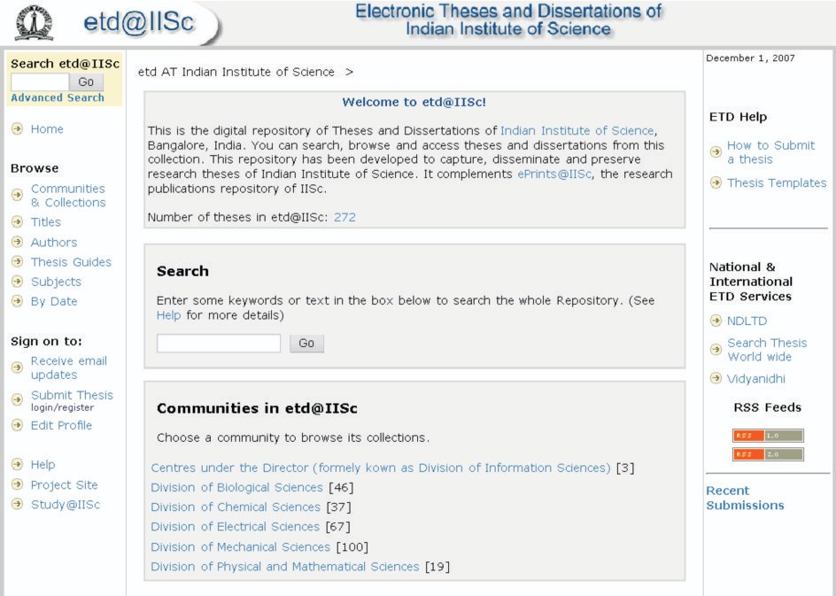

Type of Initiative: Institutional Repository / Electronic Theses and Dissertations (ETD)

Principal Implementing Agency: National Centre for Science Information (NCSI), Indian Institute of Science (IISc), Bangalore

Supporting Agency: Indian Institute of Science (IISc), Ministry of Human Resource Development, Government of India

Software Used: DSpace

Web Address: [http://etd.ncsi.iisc.ernet.in](http://etd.ncsi.iisc.ernet.in/) Allied Projects:

•EPrints @ IISc <http://eprints.iisc.ernet.in/>

•Cross Archive Search Service for Indian Repositories (CASSIR)

98

[http://casin.ncsi.iisc.ernet.in/oai/](http://casin.ncsi.iisc.ernet.in/oai)



•INDEST Consortium (Indian National Digital Library in Engineering Sciences and [Technology)](http://vidya-mapak.Technology/) <http://indest.iitd.ac.in/>

•[PRABHAVI: Indian Institute of Science Publications Database http://vidya- mapak.ncsi.iisc.ernet.in/cgi-bin/library](http://vidya-mapak.Technology/)

•Sci-Gate: The IISc Science Information Portal <http://www.ncsi.iisc.ernet.in/>

•Scientific Journal Publishing in India: Indexing and Online Management <http://sjpi.ncsi.iisc.ernet.in/>

•LIS-Forum - Discussion Forum for Library and Information Professionals in India <http://ncsi.iisc.ernet.in/mailman/listinfo/lis-forum>

•KM-Forum - Global Discussion Forum for Knowledge Management <http://ncsi.iisc.ernet.in/mailman/listinfo/km-forum>

##### Brief Description:

The ETD@IISc is an institutionally acclaimed open access theses and dissertations repository of the Indian Institute of Science - a joint service of the National Centre for Science Information (NCSI) and the IISc Library. This repository disseminates and preserves high quality research theses of the Indian Institute of Science. This service is a complement to ePrints@IISc, the research publications repository of IISc. Apart from electronic copies of recently submitted theses, this repository also includes digitized theses, where digitization of old documents is an on-going project at IISc. The Indian Institute of Science established an 'IISc INDEST User Group' that has subgroups on 'Thesis Format Guidelines', 'Copyright Issues' and 'Technology Issues for Archival and Online Hosting'. ETD@IISc hosts some operational guidelines and agreement forms, derived from the recommendations of the User Group, for the perusal of IISc researchers and members of the INDEST Consortium. Over the time this ETD initiative has become a role model amongst the members of INDEST Consortium. The INEDEST Consortium has a strong advocacy role in the formulation of policy for establishment of open access ETD repositories and/or open access institutional repositories in its respective member institutions.

The record display page of individual thesis provides links to full-text objects, along with descriptive metadata such as title, author, subject, keywords, date of submission, publisher, abstract, URI, and the name of collection. Figure 22 shows the distribution of electronic theses in the repository by subject, that depicts Division of Mechanical Sciences has maximum contribution to this open access archive.

This repository is compliant to OAI-PMH (Protocol for Metadata Harvesting) and indexed in the CASSIR (Cross Archive Search Service for Indian Repositories), OAIster and OpenDOAR (Directory of Open Access Repositories).

99

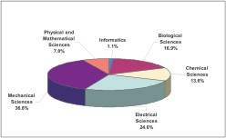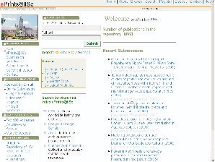

Figure 22: Distribution of Electronic Theses in ETD@IISc by Subject Division

### Open Access Repository of IISc Research Publications (ePrints@IISc)

100

Type of Initiative: Institutional Repository



Principal Implementing Agency: National Centre for Science Information (NCSI), Indian Institute of Science (IISc), Bangalore

Supporting Agency: Indian Institute of Science (IISc), Ministry of Human Resource Development, Government of India

Software Used: EPrints

Web Address: <http://eprints.iisc.ernet.in/> Allied Projects:

•ETD @ IISc [http://etd.ncsi.iisc.ernet.in](http://etd.ncsi.iisc.ernet.in/)

•Cross Archive Search Service for Indian Repositories (CASSIR) [http://casin.ncsi.iisc.ernet.in/oai/](http://casin.ncsi.iisc.ernet.in/oai)

•INDEST Consortium (Indian National Digital Library in Engineering Sciences and Technology) <http://indest.iitd.ac.in/>

•[PRABHAVI: Indian Institute of Science Publications Database http://vidya- mapak.ncsi.iisc.ernet.in/cgi-bin/library](http://indest.iitd.ac.in/)

•Sci-Gate: The IISc Science Information Portal [http://www.ncsi.iisc.ernet.in/](http://vidya-mapak.www.ncsi.iisc.ernet.in/)

•Scientific Journal Publishing in India: Indexing and Online Management <http://sjpi.ncsi.iisc.ernet.in/>

•LIS-Forum - Discussion Forum for Library and Information Professionals in India <http://ncsi.iisc.ernet.in/mailman/listinfo/lis-forum>

•KM-Forum - Global Discussion Forum for Knowledge Management <http://ncsi.iisc.ernet.in/mailman/listinfo/km-forum>

##### Brief Description:

The Indian Institute of Science (IISc), located at Bangalore, is India's most renounced research institution having a world class reputation in the research areas of applied sciences and technologies. The Open Access Repository of IISc Research Publications (ePrints@IISc) is one of oldest open access channels in India, having about 8700 full-text research literature largest amongst Indian institutional repositories. This institutional repository collects, preserves and disseminates intellectual outputs of IISc research community, available in digital format. The research community can self-deposit their scholarly publications using a web interface, and organize these publications for easy retrieval. While ePrints@IISc can be accessed by anybody across the world, submission of documents to this repository is limited to the IISc research community. This repository is compliant to OAI-PMH (Protocol for Metadata Harvesting) and indexed in the CASSIR (Cross Archive Search Service for Indian Repositories), OAISter, Google Scholar and OpenDOAR (Directory of Open Access Repositories). While search engines accelerate access to full-text contents in this repository, the international visibility of research publications archived in this repository increases manifold.

101

### IDRC Digital Library

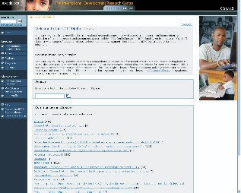

Type of Initiative: Institutional Repository

Principal Implementing Agency: International Development Research Centre, Ottawa, Canada

Participating Institution (Sub-Regional): International Development Research Centre, South Asian Regional Office, New Delhi

Supporting Agencies (Overseas): International Development Research Centre, Ottawa, Canada Software Used: DSpace

Web Address 1: <http://idl-bnc.idrc.ca/>

Web Address 2: [https://idl-bnc.idrc.ca/dspace/](https://idl-bnc.idrc.ca/dspace)

##### Brief Description:

The International Development Research Centre (IDRC) is a Canadian government corporation that helps the people of developing countries design and conduct research to solve their own

102

development problems. IDRC emphasizes building the capacity of its partners to be able to creatively respond to the challenges they face, wherever they are. The Regional Office for South Asia and China of IDRC is located in New Delhi and is mainly responsible for delivering IDRC's programme of research support to development activities in Afghanistan, Bangladesh, Bhutan, China, India, Maldives, Nepal, Pakistan and Sri Lanka. The IDRC Digital Library provides access to a current and comprehensive collection of research results and documents generated by IDRC- funded projects, IDRC-supported researchers and IDRC staff about a wide range of subjects related to international development on four broad themes - environment and natural resource management, information and communication technologies for development, innovation policy and science, and social and economic policy. This digital archive has a collection called *Pan Asia* that provides access to documents depicting results of research conducted in Asian region. The IDRC Digital Library includes research publications in different formats, such as:



•Books

•Conference Papers

•Conference Proceedings

•Evaluation Reports

•Journal Articles

•Project Reports

•Technical Reports

•Theses and Dissertations

•Working Papers

•Workshop Reports

This repository is compliant to OAI-PMH (Protocol for Metadata Harvesting) and indexed in the OpenDOAR (Directory of Open Access Repositories), Google Scholar and OAIster.

103

### Digital Repository of IIT Bombay

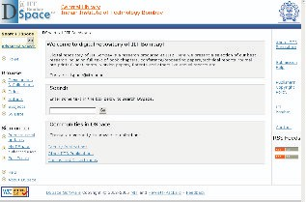

Type of Initiative: Institutional Repository

Principal Implementing Agency: Central Library, Indian Institute of Technology Bombay

Supporting Agency: Indian Institute of Technology Bombay (IITB), Ministry of Human Resource Development, Government of India

Software Used: DSpace

Web Address: [http://dspace.library.iitb.ac.in/dspace/](http://dspace.library.iitb.ac.in/dspace)

##### Brief Description:

The Indian Institute of Technology Bombay is an internationally acclaimed technological institution in India. The Digital Repository of IIT Bombay is now a prototype system, providing access to faculty publications. This repository strives to become a reliable and open access scholarly communication channel for disseminating research publications produced by the research community in the institute. This repository covers in applied science, engineering and technology areas.

104

### DSpace at National Centre for Radio Astrophysics



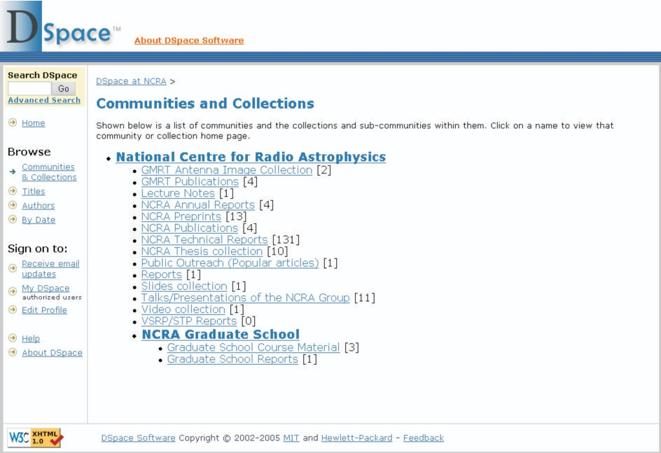

Type of Initiative: Institutional Repository

Principal Implementing Agency: National Centre for Radio Astrophysics (NCRA), Pune Participating Institution: Giant Metrewave Radio Telescope (GMRT), Pune

Supporting Agency: Tata Institute of Fundamental Research (TIFR), Department of Atomic Research (DAE), Government of India

Software Used: DSpace

Web Address: [http://ncralib.ncra.tifr.res.in:8080/dspace/](http://ncralib.ncra.tifr.res.in:8080/dspace)

##### Brief Description:

The National Centre for Radio Astrophysics (NCRA) is a premier Indian research centre in the area of radio astrophysics and astronomy. NCRA provides a unique facility for radio astronomical

105

research at metre wavelengths, called Giant Metrewave Radio Telescope (GMRT). GMRT is a very versatile instrument for investigating a variety of radio astrophysical problems ranging from nearby Solar system to the edge of observable Universe. DSpace at NCRA provides access to research publications produced by researchers of this centre. Presently major collections consist of technical reports, theses and journal articles, where some research publications are based on data from the GMRT facility.

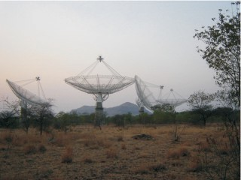

Figure 23: Giant Metrewave Radio Telescope (GMRT) Facility at NCRA, Pune

106

### Digital Repository Service at National Institute of Oceanography



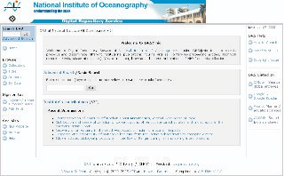

Type of Initiative: Institutional Repository

Principal Implementing Agency: National Information Centre for Marine Sciences (NICMAS), National Institute of Oceanography, Goa

Supporting Agency: National Institute of Oceanography, Council of Scientific and Industrial Research (CSIR), Government of India

Software Used: DSpace

Web Address: <http://drs.nio.org/>

Related Project: CSIR Explorations <http://csirexplorations.com/>

##### Brief Description:

The National Institute of Oceanography (NIO), India is a premier research institution devoted to interdisciplinary research in oceanography, marine sciences and Antarctic sciences. The NIO Digital Repository Service (DRS) is an institutional repository disseminating full-text institutional publications, such as journal articles, conference papers, conference proceedings, technical reports, theses, and dissertations. The publications are self-archived by its researchers and scientists. This repository covers interdisciplinary subject areas related to oceanography and

107

marine sciences. The collections of this repository are arranged by basic subjects, such as:

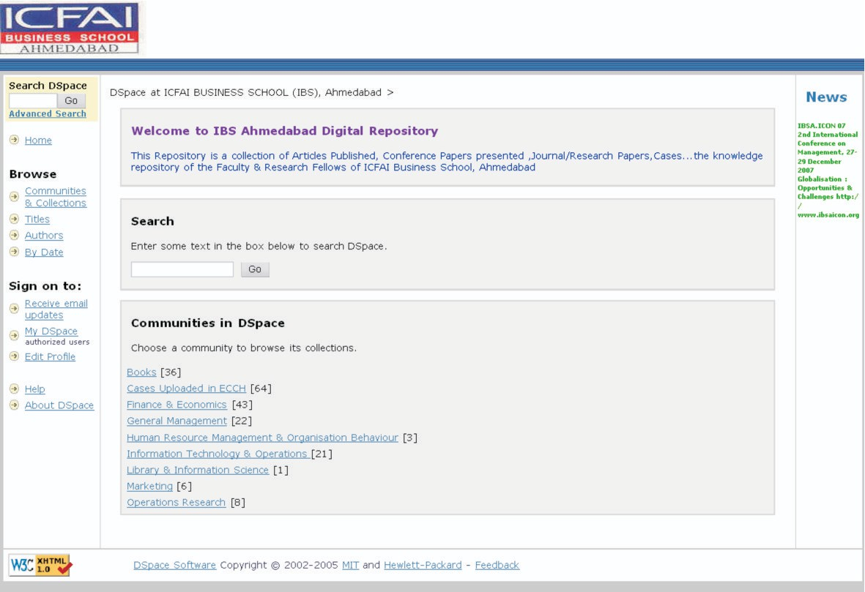

➢Biological Sciences

➢Chemical Sciences

➢Engineering and Instrumentation

➢Geology and Geophysical Sciences

➢Interdisciplinary Oceanography

➢Marine Archaeology

➢Materials Sciences

➢Miscellaneous

➢Physical Sciences

This repository is compliant to OAI-PMH (Protocol for Metadata Harvesting) and indexed in the CASSIR (Cross Archive Search Service for Indian Repositories), and OpenDOAR (Directory of Open Access Repositories).

### ICFAI Business School Ahmedabad Digital Repository

108

Type of Initiative: Institutional Repository



Principal Implementing Agency: ICFAI Business School, Ahmedabad, India Supporting Agency: Institute of Chartered Financial Analysts of India (ICFAI) Software Used: DSpace

Web Address: <http://202.131.96.59:8080/dspace>

##### Brief Description:

The ICFAI Business School is a private sector management institute having branches all over the country. ICFAI Business School, Ahmedabad has established an institutional repository harbouring publications produced by the Institute's students and faculty members in the areas of management sciences, economics, planning, mathematics, statistics, and information science. This repository stores publications such as journal articles, case studies, conference papers, conference proceedings, unpublished documents, research reports, books and learning materials. It is compliant to OAI-PMH (Protocol for Metadata Harvesting) and indexed in the CASSIR (Cross Archive Search Service for Indian Repositories), and OpenDOAR (Directory of Open Access Repositories).

### DSpace@IIMK

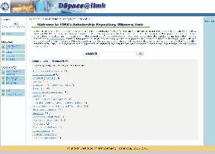

109

Type of Initiative: Institutional Repository

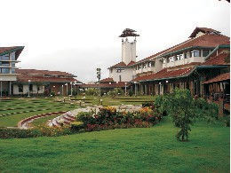

Principal Implementing Agency: Indian Institute of Management Kozhikode**,** India

Supporting Agency: Indian Institute of Management Kozhikode, Ministry of Human Resource Development, Government of India

Software Used: DSpace

Web Address: <http://dspace.iimk.ac.in/>

Allied Projects: Greenstone Support for South Asia <http://greenstonesupport.iimk.ac.in/>; IIMK Digital Library <http://www.iimk.ac.in/gsdl/cgi-bin/library>

##### Brief Description:

The Indian Institute of Management Kozhikode (IIM Kozhikode) is one of the top business schools in the country, involved in academic and sponsored research in the interdisciplinary areas of economics, management, trade, commerce, industries and related areas. The DSpace@IIMK is an institutional repository of the IIM Kozhikode. This repository provides open access archiving facilities to the IIMK communities such as faculty members, students and researchers, to reach worldwide audiences and to improve impact of their research. It covers book reviews, case studies, journal articles, conference papers, working papers and conference proceedings in the areas of management, business, economics, communication, and social sciences. It facilitates self- archiving and long-term preservation of scholarly publications. It is compliant to OAI-PMH (Protocol for Metadata Harvesting) and indexed in the CASSIR (Cross Archive Search Service for Indian Repositories), and OpenDOAR (Directory of Open Access Repositories).

Figure 24: IIMK Campus, hosting DSpace@IIMK

110

### Indian Institute of Astrophysics Repository



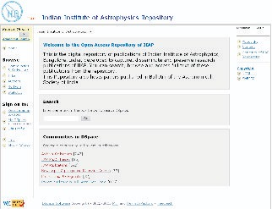

Type of Initiative: Institutional Repository

Principal Implementing Agency: Indian Institute of Astrophysics, Bangalore

Participating Institutions: Astronomical Society of India; Vainu Bappu Observatory, Kavalur; Madras Observatory, Chennai; Kodaikanal Solar Observatory, Kodaikanal

Supporting Agency: Indian Institute of Astrophysics, Ministry of Science and Technology, Government of India

Software Used: DSpace

Web Address: <http://prints.iiap.res.in/>

##### Brief Description:

The Indian Institute of Astrophysics (IIAP) is a premier research institution devoted to research in astronomy, astrophysics and related physics. IIAP hosts Asia's finest astronomical observing facilities, located at Gauribidanur, Hanle, Kavalur and Kodaikanal. The IIAP Repository is the open access institutional repository, developed to capture, disseminate and preserve research

111

publications of the IIAP. The repository also gives access to full-text contents of current and back volumes of *Bulletin of the Astronomical Society of India* from volume one in 1973. This repository hosts the following collections:



* Archival Collections
* IIAP PhD Theses
* IIAP Publications such as journal articles, conference papers and preprints of IIAP scientists and researchers
* Research publications based on data from Indian Astronomical Observatory
* Newspaper Clippings and Magazine Articles on IIAP
* IIAP Profiles and Photographs
* Papers published in *Bulletin of the Astronomical Society of India*

The content in Archival Collections include old records, manuscripts, publications and photographs of people and instruments belonging to the Madras and Kodaikanal Observatories and IIAP branch offices in Bangalore, Kavalur and Leh during 18th, 19th and early 20th Century. This repository is compliant to OAI-PMH (Protocol for Metadata Harvesting) and indexed in the CASSIR (Cross Archive Search Service for Indian Repositories), OAIster and OpenDOAR (Directory of Open Access Repositories).

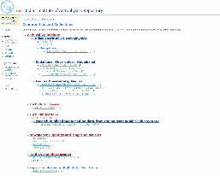

Figure 25: IIAP Repository Communities and Collections

112

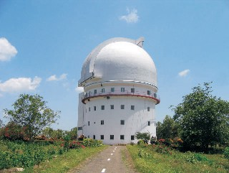

Figure 26: Vainu Bappu Observatory, Kavalur, hosting Asia's Largest Telescope an Astronomical Treasure for Amateur and Professional Astronomers

### DSpace at National Chemical Laboratory

Type of Initiative: Institutional Repository

Principal Implementing Agency: National Chemical Laboratory**,** Pune

Supporting Agency: National Chemical Laboratory, Council of Scientific and Industrial Research (CSIR), Ministry of Science and Technology, Government of India

113

Software Used: DSpace



Web Address: [http://dspace.ncl.res.in/dspace/](http://dspace.ncl.res.in/dspace)

Allied Projects: Moltable (Chemoinformatics Portal) <http://moltable.ncl.res.in/> ; CSIR Explorations <http://csirexplorations.com/>

##### Brief Description:

The DSpace@NCL is an institutional repository of the National Chemical Laboratory, a premier public R&D institution of Council of Scientific and Industrial Research (CSIR). This repository provides open access archiving facilities to the NCL communities such as scientists and researchers, to reach worldwide and to improve impact of their scholarly publications. The majority of material currently consists of PhD theses and patents. It also covers research papers of NCL scientists, technical reports, project reports, research reports, journal articles and conference papers in different areas of chemical sciences and chemical technologies. It facilitates self-archiving and long-term preservation of scholarly publications. Using this facility, registered users can set up email alerts to notify them of newly added relevant content. This repository is compliant to OAI- PMH (Protocol for Metadata Harvesting) and indexed in the CASSIR (Cross Archive Search Service for Indian Repositories), OAIster and OpenDOAR (Directory of Open Access Repositories).

### DSpace@INFLIBNET

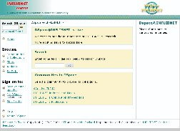

114

Type of Initiative: Institutional Repository



Principal Implementing Agency: Information and Library Network (INFLIBNET) Centre, Ahmedabad

Participating Institutions: UGC-recognized Universities in India

Supporting Agency (Indian): University Grants Commission (UGC), Ministry of Human Resource Development, Government of India

Software Used: DSpace

Web Address: <http://dspace.inflibnet.ac.in/> Allied Projects:

•UGC Infonet [http://web.inflibnet.ac.in/UGC-InfoNet/](http://web.inflibnet.ac.in/UGC-InfoNet), <http://unicat.inflibnet.ac.in/econ/mindex.htm>

•National Online Union Catalogue [http://202.141.12.214:8080/unicat/](http://202.141.12.214:8080/unicat)

##### Brief Description:

The Information and Library Network (INFLIBNET) Centre, India is an autonomous Inter- University Centre (IUC) of University Grants Commission (UGC), involved in creating information infrastructure for academic and research institutions, particularly for universities and colleges in India. The INFLIBNET Centre organizes two annual conventions, namely, CALIBER and 'Promotion of Library Automation and Networking in North Eastern Region' (PLANNER). This institutional repository contains proceedings of CALIBER and PLANNER. It also provides full-text access to collections such as, dArchive India (Digital Academic and Research Content for Value Education), news clippings about INFLIBNET, INFLIBNET publications including newsletters and Regional Training Programme in Library Automation (RTPLA) course materials. It is compliant to OAI-PMH (Protocol for Metadata Harvesting) and indexed in the CASSIR (Cross Archive Search Service for Indian Repositories), OAIster and OpenDOAR (Directory of Open Access Repositories).

115

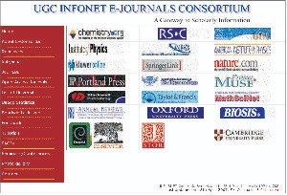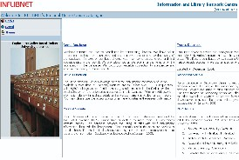

Figure 27: UGC Infonet e-Journals Consortium Gateway

Figure 28: INFLIBNET's National Online Union Catalogue

116

### DSpace at Thapar University



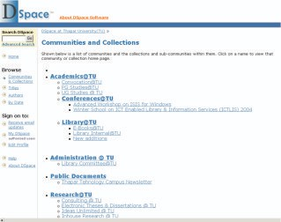

Type of Initiative: Institutional Repository

Principal Implementing Agency: Central Library, Thapar University, Patiala

Supporting Agency: Thapar University, (formerly, Thapar Institute of Engineering and Technology), Patiala

Software Used: DSpace

Web Address: [http://dspace.tiet.ac.in:8080/dspace/](http://dspace.tiet.ac.in:8080/dspace)

##### Brief Description:

Thapar University, India is a privately managed grant-in-aid technical university, located in the Punjab. DSpace at Thapar University is an institutional repository that collects, preserves and disseminates the intellectual outputs of the host institution to the global audience. At present, it

117

provides access to full-text contents of electronic theses and dissertations (ETD), workshop proceedings, journal articles, and conference papers authored by its researchers and faculty members. The scholarly literature is arranged in this repository in following collections: Academics@TU, Administration@TU, Public Documents and Research@TU. Registered users of the portal can get email alerts on regular intervals to notify them of newly added relevant contents. In association with UNESCO, Thapar University conducted an Advanced Workshop on ISIS for Windows in year 2007. The training modules are now available in this repository.



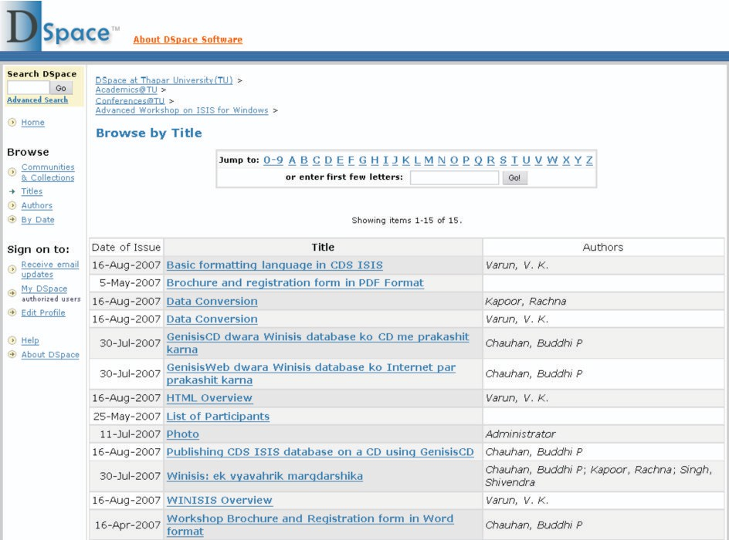

Figure 29: Open Access Training Modules available at TU Institutional Repository

118

### University of Delhi EPrint Archive

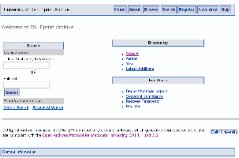

Type of Initiative: Institutional Repository

Principal Implementing Agency: University of Delhi, Delhi

Participating Institutions: Departments, Centres and Colleges in University of Delhi

Supporting Agency: University of Delhi, Ministry of Human Resource Development, Government of India

Software Used: EPrints

Web Address: <http://eprints.du.ac.in/>

##### Brief Description:

This institutional repository for the University of Delhi provides access to the publications of the university community such as students, researchers and faculty members located in different departments, centres and colleges. The publications pertain to journal articles, conference proceedings, conference papers, books, patents, etc. written in English language having multidisciplinary or interdisciplinary coverage. The repository follows a self-archiving submission process. This repository is compliant to OAI-PMH (Protocol for Metadata Harvesting) and indexed in the CASSIR (Cross Archive Search Service for Indian Repositories), OAIster and OpenDOAR (Directory of Open Access Repositories).

119

### Raman Research Institute Digital Repository

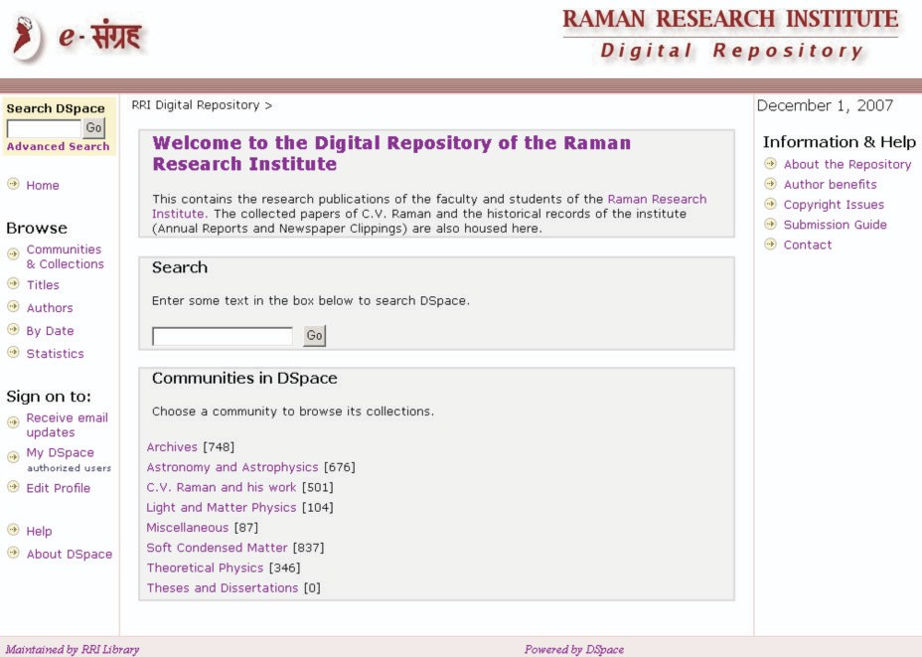

Type of Initiative: Institutional Repository

Principal Implementing Agency: Raman Research Institute Library, Bangalore

Supporting Agency: Raman Research Institute, Department of Science & Technology, Government of India

Software Used: DSpace

Web Address: [http://dspace.rri.res.in:8080/dspace/](http://dspace.rri.res.in:8080/dspace)

##### Brief Description:

The Raman Research Institute (RRI), India founded by Nobel laureate Sir C.V.Raman in 1948, is a premier research centre in the area of physical science. The RRI Digital Repository is an institutional repository providing worldwide access to the research publications, contributed by the

120

faculty members and scholars of the institute. This repository has already archived approximately 500 collected papers of C.V. Raman and other historical records of the Institute. It consists of the following collections: Archives (annual reports, Gandhi Memorial lectures and newspaper clippings), Astronomy and Astrophysics, C.V. Raman and his work, Light and Matter Physics, Soft Condensed Matter, Theoretical Physics, and Miscellaneous Publications. This repository is compliant to OAI-PMH (Protocol for Metadata Harvesting) and indexed in the CASSIR (Cross Archive Search Service for Indian Repositories), OAIster and OpenDOAR (Directory of Open Access Repositories).



### EPrints and ETD at Indian Institute of Technology Delhi

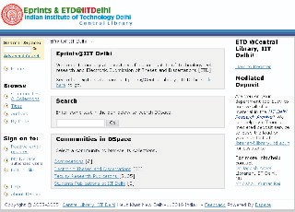

Type of Initiative: Institutional Repository

Principal Implementing Agency: Central Library, Indian Institute of Technology Delhi

121

Supporting Agency: Indian Institute of Technology Delhi, Ministry of Human Resource Development, Government of India

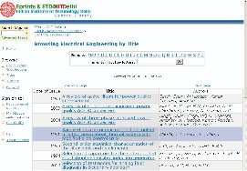

Software Used: DSpace

Web Address: [http://eprint.iitd.ac.in/dspace/](http://eprint.iitd.ac.in/dspace)

Allied Project: INDEST Consortium (Indian National Digital Library in Engineering Sciences and Technology) <http://indest.iitd.ac.in/>

##### Brief Description:

The Indian Institute of Technology Delhi is an internationally acclaimed technological institution in India. The EPrints at IIT Delhi is one of the oldest open access archives in India, providing worldwide access to scholarly literature, authored by faculty members and research scholars. This repository is becoming a reliable open access scholarly communication channel for disseminating research publications produced by research community in the institute. It also includes convocation addresses and electronic theses and dissertations (ETD). EPrints at IIT Delhi has coverage in applied science, engineering and technology areas. The administrator of this repository offers a mediated deposit service to archive publications on behalf of a faculty member. This repository is compliant to OAI-PMH (Protocol for Metadata Harvesting) and indexed in the CASSIR (Cross Archive Search Service for Indian Repositories), Google Scholar, OAIster and OpenDOAR (Directory of Open Access Repositories).

Figure 30: Navigating EPrints@IITDelhi by Selecting *Communities & Collections*

122

### Digital Repository at Management Development Institute



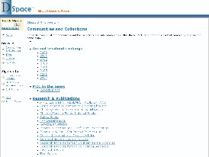

Type of Initiative: Institutional Repository

Principal Implementing Agency: Management Development Institute Library, Gurgaon Supporting Agency: Management Development Institute (MDI), India

Software Used: DSpace

Web Address: [http://dspace.mdi.ac.in/dspace/](http://dspace.mdi.ac.in/dspace)

##### Brief Description:

The Management Development Institute (MDI), Gurgaon is a leading business school in India. The MDI Digital Repository is an institutional repository providing worldwide access to the research publications, contributed by the faculty members and scholars of the institute. It also provides access to annual B-School rankings (published in news magazines) and MDI in the news (news clippings), in addition to multidisciplinary /interdisciplinary research publications of researchers and faculty members (such as journal articles, conference papers and business case studies). This repository is compliant to OAI-PMH (Protocol for Metadata Harvesting) and indexed in the CASSIR (Cross Archive Search Service for Indian Repositories), OAIster and OpenDOAR (Directory of Open Access Repositories).

123

### National Aerospace Laboratories Institutional Repository (NAL Repository)

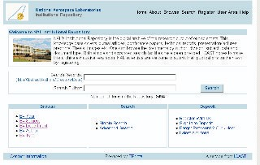

Type of Initiative: Institutional Repository

Principal Implementing Agency: Information Centre for Aerospace Science and Technology (ICAST), National Aerospace Laboratories, Bangalore

Supporting Agency: National Aerospace Laboratories, Council of Scientific and Industrial Research (CSIR), Ministry of Science and Technology, Government of India

Software Used: EPrints

Web Address: <http://nal-ir.nal.res.in/> Allied Projects:

•AeroInfo: Aerospace Virtual Library [http://www.aeroinfo.org.in](http://www.aeroinfo.org.in/)

•Aerospace News Clippings <http://www.icast.org.in/news/newsclips.php>

##### Brief Description:

The National Aerospace Laboratories (NAL), established in 1959, is India's greatest R&D establishment in aeronautics and allied disciplines. NAL's Institutional Repository is the open access digital archive for the research outputs of NAL scientists. This knowledge-base comprises project documents, technical reports, journal articles, conference papers and workshop papers. The

124

documents in this repository can be browsed by year, subject, department, author and type of publications. Both simple and advanced search facilities have been provided. NAL scientists can submit their publications on their own, after a one-time user registration process. The NASA Aerospace Subject Heading is assigned in each record of this database, where main subject categories under this subject heading scheme are as follows:



•Aeronautics

•Astronautics

•Chemistry and Materials

•Engineering

•General

•Geosciences

•Life Sciences

•Mathematical and Computer Sciences

•Physics

•Social and Information Sciences

•Space Sciences

This repository is compliant to OAI-PMH (Protocol for Metadata Harvesting) and indexed in the CASSIR (Cross Archive Search Service for Indian Repositories), Google Scholar, OAIster and OpenDOAR (Directory of Open Access Repositories).

125

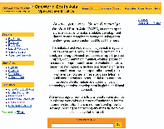

Figure 31: Saras 2, Developed by National Aerospace Laboratories

### OneWorld South Asia Open Archive Initiative

126

Type of Initiative: Institutional Repository



Principal Implementing Agency: OneWorld South Asia, New Delhi Supporting Agency: OneWorld International Foundation, UK Software Used: EPrints

Web Address: <http://open.ekduniya.net/>

Allied Projects:

•Digital Opportunity Channel [www.digitalopportunity.org](http://www.digitalopportunity.org/)

•Initiative on Social Justice [http://socialjustice.ekduniya.net](http://socialjustice.ekduniya.net/)

##### Brief Description:

OneWorld South Asia (OWSA) is an international civil society organization located at New Delhi, having a network of 500 grassroots organisations dedicated to voicing the voiceless and exploring the role of ICTs in achieving the Millennium Development Goals (MDGs). OWSA undertakes several initiatives to build and strengthen Communities of Practice (CoPs) around the MDGs to facilitate knowledge and information sharing in the region. OWSA is also involved in programmes related to grassroots communication, knowledge for development, capacity building, networking, advocacy and awareness raising. The OWSA Open Archive Initiative is a knowledge and information sharing initiative, launched to disseminate development literature generated by OWSA partner organizations and other development practitioners working in this sub-region. This open access repository provides access to books, monographs, book chapters, workshop materials, training modules, media articles, conference papers, presentations and journal articles. The documentary resources available here are mostly related to aspects of ICT-enabled development in global and local context. The documents available in this archive cover following sub-categories:

•Access to Information

•Building Confidence, Trust and Security

•Capacity Building

•Cultural and Linguistic Diversity, Local Content

•Enabling Environment (Policy, Legal and Regulatory Framework)

•Ethical Dimensions of the Information Society

•ICT Applications for Development

•Inclusive Information Society

•Information and Communication Infrastructure

•Media

This repository is compliant to OAI-PMH (Protocol for Metadata Harvesting) and indexed in the CASSIR (Cross Archive Search Service for Indian Repositories), Google Scholar, OAIster and OpenDOAR (Directory of Open Access Repositories).

127



**CONCLUSION**

Open access to knowledge and information as we may see from this listing has far to go in South Asia. It is largely achievable in a country where policy frameworks, institutional frameworks, information infrastructure, trained manpower, and financial resources are adequately available. The effect of focused capacity building programmes in the areas of digital preservation, digital libraries and open access to literature is encouraging in a country like India, where significant proliferation of open access and digital library initiatives have been achieved in the last decade. A number of workshops and training events were organized in India during this period, where a few thousand library and computer professionals received training in open source software for building open access repositories. Library schools in India have since included open source digital archiving software in their curricula. Several national and international conferences, seminars, and symposia were also organized in India, where library professionals discussed methods and techniques of digitization, digital library development, institutional repository development and digital preservation. India has now become the leader in digital library and open access initiatives in South Asia and across Asia, due to stakeholders' active participation in capacity building processes as well as the availability of financial resources. The key to commitment and development in this field lies in the sensitization of stakeholders as which has been done in India. In Pakistan, policy and institutional frameworks are being reinforced to embrace open access initiatives. In other South Asian countries such as Afghanistan, Bangladesh, Bhutan, Nepal, Maldives and Sri Lanka, however, there remains significant room for more awareness raising, capacity building, and sensitization programmes involving stakeholders in order to achieve that paradigm shift in universal access to information, knowledge and heritage.

The sustainability of open access portals is another issue that requires proper attention. Too often, the open access portal in an institution may remain non-functional due to some internal dynamics, pointing to the need for introduction and maintenance of proper institutional frameworks and manpower development in this field. Coordinators of self-archived institutional repositories may also sensitize community members on the importance of open access to knowledge and provide training in self-archiving methods on a regular basis.

Open access to South Asian literature both scholarly communications and development-related literature ensures global visibility and accessibility, resulting in increased global recognition. Open access to information and knowledge not only enables digital inclusion of common citizens, particularly under-privileged communities, but also bridges social divides.

128

## REFERENCES



•Ambati, Vamshi... [et al] (2006). The Digital Library of India Project: Process, Policies and Architecture. Available [at: http://www.iiit.net/techreports/waiting/2007_45.pdf](http://www.iiit.net/techreports/waiting/2007_45.pdf)

•Chan, Leslie; Kirsop, Barbara and Arunachalam, Subbiah (2005). Open Access Archiving: the fast track to building research capacity in developing countries. SciDev.Net November 2005. Available at: <http://www.scidev.net/open_access/files/Open%20Access%20Archiving.pdf>

•Dabla, Amitabh. Digital Library: Pilot Testing in Karnataka, India. Bangalore: Education Development Center (EDC). Available at: <http://ies.edc.org/T4India/resources/Digital%20Library%20Pilot%20Testing%20in%20> Karnataka.pdf

•Das, Anup Kumar; Dutta, Chaitali and Sen, BK (2007). Information Retrieval Features in Indian Digital Libraries: A Critical Appraisal. OCLC Systems & Services: International Digital Library Perspectives, 23(1) 92-104.

•Fernandez, Leila (2006). Open Access Initiatives in India - an Evaluation. Partnership: the Canadian Journal of Library and Information Practice and Research, 1(1). Available [at: http://journal.lib.uoguelph.ca/index.php/perj/article/viewArticle/110/171](http://journal.lib.uoguelph.ca/index.php/perj/article/viewArticle/110/171)

•Ghosh, SB and Das, Anup Kumar (2007). Open Access and Institutional Repositories - a Developing Country Perspective: A Case Study of India. IFLA Journal, 33(3), 229-250. Available [at: http://www.ifla.org/V/iflaj/IFLA-Journal-3-2007.pdf](http://www.ifla.org/V/iflaj/IFLA-Journal-3-2007.pdf)

•National Knowledge Commission (2006). Report to the Nation 2006. New Delhi: National Knowledge Commission. Available at: [http://knowledgecommission.gov.in/report2006/](http://knowledgecommission.gov.in/report2006)

•National Knowledge Commission (2007). Report of the Working Group on Open Access and Open Educational Resources. New Delhi: National Knowledge Commission. Available at: <http://knowledgecommission.gov.in/downloads/documents/wg_open_course.pdf>

•National Knowledge Commission (2007). Report of the Working Group on Libraries. New Delhi: National Knowledge Commission. Available at: <http://knowledgecommission.gov.in/downloads/documents/wg_lib.pdf>

•Sood, Aditya Dev and Chandrasekharan, Uma (2004). Digital Libraries in India: A Baseline Survey. New Delhi: Center for Knowledge Societies. Available at: <http://www.cks.in/html/cks_pdfs/digital_library_cks-edc.pdf>

•TDIL Programme (2005). Digital Library Special Issue, Vishwabharat@TDIL, 17, April 2005. Available [at: http://tdil.mit.gov.in/apr_2005.htm](http://tdil.mit.gov.in/apr_2005.htm)

•University Grants Commission (2005). UGC (Submission of Metadata and Full-text of Doctoral Theses in Electronic Format) Regulations. Available at: [www.ugc.ac.in/new_initiatives/etd_hb.pdf](http://www.ugc.ac.in/new_initiatives/etd_hb.pdf)

129

## ANNEXURE



#### WSIS Declaration of Principles

**Building the Information Society: A Global Challenge in the New Millennium**

##### Access to Information and Knowledge

The ability for all to access and contribute information, ideas and knowledge is essential in an inclusive Information Society.

The sharing and strengthening of global knowledge for development can be enhanced by removing barriers to equitable access to information for economic, social, political, health, cultural, educational, and scientific activities and by facilitating access to public domain information, including by universal design and the use of assistive technologies.

A rich public domain is an essential element for the growth of the Information Society, creating multiple benefits such as an educated public, new jobs, innovation, business opportunities, and the advancement of sciences. Information in the public domain should be easily accessible to support the Information Society, and protected from misappropriation. Public institutions such as libraries and archives, museums, cultural collections and other community-based access points should be strengthened so as to promote the preservation of documentary records and free and equitable access to information.

Access to information and knowledge can be promoted by increasing awareness among all stakeholders of the possibilities offered by different software models, including proprietary, open-source and free software, in order to increase competition, access by users, diversity of choice, and to enable all users to develop solutions which best meet their requirements. Affordable access to software should be considered as an important component of a truly inclusive Information Society.

We strive to promote universal access with equal opportunities for all to scientific knowledge and the creation and dissemination of scientific and technical information, including open access initiatives for scientific publishing.

*Excerpt from: Geneva Declaration of Principles* [*www.itu.int/wsis/docs/geneva/official/dop.html*](http://www.itu.int/wsis/docs/geneva/official/dop.html)

130

### WSIS Plan of Action



**C3. Access to Information and Knowledge**

ICTs allow people, anywhere in the world, to access information and knowledge almost instantaneously. Individuals, organizations and communities should benefit from access to knowledge and information.

Develop policy guidelines for the development and promotion of public domain information as an important international instrument promoting public access to information.

Governments are encouraged to provide adequate access through various communication resources, notably the Internet, to public official information. Establishing legislation on access to information and the preservation of public data, notably in the area of the new technologies, is encouraged.

Promote research and development to facilitate accessibility of ICTs for all, including disadvantaged, marginalized and vulnerable groups.

Governments, and other stakeholders, should establish sustainable multi-purpose community public access points, providing affordable or free-of-charge access for their citizens to the various communication resources, notably the Internet. These access points should, to the extent possible, have sufficient capacity to provide assistance to users, in libraries, educational institutions, public administrations, post offices or other public places, with special emphasis on rural and underserved areas, while respecting intellectual property rights (IPRs) and encouraging the use of information and sharing of knowledge.

Encourage research and promote awareness among all stakeholders of the possibilities offered by different software models, and the means of their creation, including proprietary, open-source and free software, in order to increase competition, freedom of choice and affordability, and to enable all stakeholders to evaluate which solution best meets their requirements.

Governments should actively promote the use of ICTs as a fundamental working tool by their citizens and local authorities. In this respect, the international community and other stakeholders should support capacity building for local authorities in the widespread use of ICTs as a means of improving local governance.

Encourage research on the Information Society, including on innovative forms of networking, adaptation of ICT infrastructure, tools and applications that facilitate accessibility of ICTs for all, and disadvantaged groups in particular.

Support the creation and development of a digital public library and archive services, adapted to the Information Society, including reviewing national library strategies and legislation, developing a global understanding of the need for "hybrid libraries", and fostering worldwide cooperation between libraries.

Encourage initiatives to facilitate access, including free and affordable access to open access journals and books, and open archives for scientific information.

131

Support research and development of the design of useful instruments for all stakeholders to foster increased awareness, assessment, and evaluation of different software models and licences, so as to ensure an optimal choice of appropriate software that will best contribute to achieving development goals within local conditions.



**C7. ICT applications: Benefits in All Aspects of**

##### E-science Life

•Promote electronic publishing, differential pricing and open access initiatives to make scientific information affordable and accessible in all countries on an equitable basis.

**C8. Cultural Diversity and Identity, Linguistic Diversity and Local Content**

•Develop national policies and laws to ensure that libraries, archives, museums and other cultural institutions can play their full role of content - including traditional knowledge - providers in the Information Society, more particularly by providing continued access to recorded information.

•Support efforts to develop and use ICTs for the preservation of natural and, cultural heritage, keeping it accessible as a living part of today's culture. This includes developing systems for ensuring continued access to archived digital information and multimedia content in digital repositories, and support archives, cultural collections and libraries as the memory of humankind.

•Support local content development, translation and adaptation, digital archives, and diverse forms of digital and traditional media by local authorities. These activities can also strengthen local and indigenous communities.

•Provide content that is relevant to the cultures and languages of individuals in the Information Society, through access to traditional and digital media services.

*Excerpt from: Geneva Plan of Action* [*http://www.itu.int/wsis/docs/geneva/official/poa.html*](http://www.itu.int/wsis/docs/geneva/official/poa.html)

132



**BOOK CHAPTERS INDEX**

##### Digital Library Initiatives

* AHKRC Digital Library [www.lisolutions.org/gsdl/cgi-bin/library.exe](http://www.lisolutions.org/gsdl/cgi-bin/library.exe)
* Archives of Indian Labour: Integrated Labour History Research Programme [www.indialabourarchives.org](http://www.indialabourarchives.org/)
* Child Trafficking Digital Library [www.ChildTrafficking.com](http://www.ChildTrafficking.com/)
* CSIR Explorations <http://csirexplorations.com/>
* Cultural Heritage Digital Library in Hindi <http://tdil.mit.gov.in/coilnet/ignca/welcome.html>
* Digital e-Library (Dware Dware Gyan Sampadaa/ Providing Books at Your Doorsteps) [http://mobilelibrary.cdacnoida.in](http://mobilelibrary.cdacnoida.in/)
* Digital Library of India [www.new.dli.ernet.in](http://www.new.dli.ernet.in/)[, http://dli.iiit.ac.in](http://dli.iiit.ac.in/)[, www.dli.cdacnoida.in](http://www.dli.cdacnoida.in/)
* HEC - National Digital Library [www.digitallibrary.edu.pk](http://www.digitallibrary.edu.pk/)
* In.arXiv, hosted by Institute of Mathematical Sciences, Chennai [http://in.arxiv.org](http://in.arxiv.org/)
* India Education Digital Library [www.edudl.gov.in](http://www.edudl.gov.in/)
* Indian National Digital Library in Engineering Sciences and Technology (INDEST)

Consortium <http://indest.iitd.ac.in/>

* Kalasampada: Digital Library Resources of Indian Cultural Heritage (DL-RICH) [www.ignca.nic.in/dlrich.html](http://www.ignca.nic.in/dlrich.html)
* Muktabodha: Digital Library and Archiving Project [www.muktabodhalib.org/digital_library.htm](http://www.muktabodhalib.org/digital_library.htm)
* Traditional Knowledge Digital Library [www.tkdl.res.in](http://www.tkdl.res.in/)
* [United Nations Digital Library, Islamabad, Pakistan http://library.un.org.pk/gsdl/cgi-](http://library.un.org.pk/gsdl/cgi-bin/library.exe) [bin/library.exe](http://library.un.org.pk/gsdl/cgi-bin/library.exe)
* Vidyanidhi [www.vidyanidhi.org.in](http://www.vidyanidhi.org.in/)
* Vigyan Prasar Digital Library [www.vigyanprasar.gov.in/digilib/](http://www.vigyanprasar.gov.in/digilib)

##### Open Courseware Initiatives

* CEC Learning Object Repository [www.cec-lor.edu.in](http://www.cec-lor.edu.in/)
* eGyankosh A National Digital Repository [www.egyankosh.ac.in](http://www.egyankosh.ac.in/)
* Indo-German eGurukul on Digital Libraries [http://drtc.isibang.ac.in/mmb/](http://drtc.isibang.ac.in/mmb)
* National Programme on Technology Enhanced Learning (NPTEL) [www.nptel.iitm.ac.in](http://www.nptel.iitm.ac.in/)
* NCERT Online Textbooks [www.ncert.nic.in/textbooks/testing/Index.htm](http://www.ncert.nic.in/textbooks/testing/Index.htm)
* UNESCO-SALIS e-Learning Portal [http://salisonline.org](http://salisonline.org/)

##### Open Access Journals

* e-Journals @ INSA [www.insa.ac.in](http://www.insa.ac.in/)
* Indian Academy of Sciences published Open Access Journals [www.ias.ac.in/pubs/journals/](http://www.ias.ac.in/pubs/journals)

133

* IndianJournals.Com hosted Open Access Journals [www.indianjournals.com](http://www.indianjournals.com/)
* [Kamla-Raj Enterprises published Open Access Journals www.krepublishers.com/KRE-](http://www.krepublishers.com/KRE-New-J/index.html)

[New-J/index.html](http://www.krepublishers.com/KRE-New-J/index.html)

* MEDIND@NIC: Biomedical Journals from India [http://medind.nic.in](http://medind.nic.in/)
* Medknow Publications hosted Open Access Journals [www.medknow.com/journals.asp](http://www.medknow.com/journals.asp)

##### Metadata Harvesting Services

* Cross Archive Search Service for Indian Repositories (CASSIR) [http://casin.ncsi.iisc.ernet.in/oai/](http://casin.ncsi.iisc.ernet.in/oai)
* Open Index Initiative [http://oii.igidr.ac.in](http://oii.igidr.ac.in/)
* Open J-Gate [www.openj-gate.com](http://www.openj-gate.com/)
* Scientific Journal Publishing in India: Indexing and Online Management (SJPI) <http://sjpi.ncsi.iisc.ernet.in/>
* Search Digital Libraries (SDL) [http://drtc.isibang.ac.in/sdl/](http://drtc.isibang.ac.in/sdl)

##### National Level Digital Repositories

* Catalysis Database [www.eprints.iitm.ac.in](http://www.eprints.iitm.ac.in/)
* Knowledge Community on Children in India: Turning Knowledge into Action [www.kcci.org.in](http://www.kcci.org.in/)
* Librarians' Digital Library (LDL) <https://drtc.isibang.ac.in/>
* OpenMED@NIC

<http://openmed.nic.in/>

* Pakistan Research Repository (PRR) [www.eprints.hec.gov.pk](http://www.eprints.hec.gov.pk/)
* Urban Health Gateway [http://uhrc.in/uhgateway/](http://uhrc.in/uhgateway)

##### Institutional Repositories

* Digital Archive of National Institute of Technology Rourkela [http://dspace.nitrkl.ac.in/dspace/](http://dspace.nitrkl.ac.in/dspace)
* Electronic Theses and Dissertations of Indian Institute of Science (ETD@IISc) [http://etd.ncsi.iisc.ernet.in](http://etd.ncsi.iisc.ernet.in/)
* Open Access Repository of IISc Research Publications (ePrints@IISc) <http://eprints.iisc.ernet.in/>
* IDRC Digital Library <http://idl-bnc.idrc.ca/>
* Digital Repository of IIT Bombay [http://dspace.library.iitb.ac.in/dspace/](http://dspace.library.iitb.ac.in/dspace)
* DSpace at National Centre for Radio Astrophysics [http://ncralib.ncra.tifr.res.in:8080/dspace/](http://ncralib.ncra.tifr.res.in:8080/dspace)
* Digital Repository Service at National Institute of Oceanography <http://drs.nio.org/>
* ICFAI Business School Ahmedabad Digital Repository <http://202.131.96.59:8080/dspace>
* DSpace@IIMK <http://dspace.iimk.ac.in/>
* Indian Institute of Astrophysics Repository <http://prints.iiap.res.in/>
* DSpace at National Chemical Laboratory

[http://dspace.ncl.res.in/dspace/](http://dspace.ncl.res.in/dspace)

* DSpace@INFLIBNET <http://dspace.inflibnet.ac.in/>



134

* DSpace at Thapar University [http://dspace.tiet.ac.in:8080/dspace/](http://dspace.tiet.ac.in:8080/dspace)



* University of Delhi EPrint Archive <http://eprints.du.ac.in/>
* Raman Research Institute Digital Repository [http://dspace.rri.res.in:8080/dspace/](http://dspace.rri.res.in:8080/dspace)
* EPrints and ETD at Indian Institute of Technology Delhi [http://eprint.iitd.ac.in/dspace/](http://eprint.iitd.ac.in/dspace)
* Digital Repository at Management Development Institute, Gurgaon [http://dspace.mdi.ac.in/dspace/](http://dspace.mdi.ac.in/dspace)
* [National Aerospace Laboratories Institutional Repository (NAL Repository) http://nal- ir.nal.res.in/](http://nal-ir.nal.res.in/)
* OneWorld South Asia Open Archive Initiative <http://open.ekduniya.net/>

135

## OTHER USEFUL OPEN ACCESS RESOURCES AND KNOWLEDGE PORTALS



Adult Learning Documentation and Information Network (ALADIN) [www.unesco.org/education/aladin/](http://www.unesco.org/education/aladin)

Bangladesh Development Gateway [www.bangladeshgateway.org](http://www.bangladeshgateway.org/) Bhasha Sanchar [www.bhashasanchar.org](http://www.bhashasanchar.org/)

BhashaIndia [www.bhashaindia.com](http://www.bhashaindia.com/)

CEC E-Content - E-Learning Resources for Undergraduates [www.cec-econtent.edu.in](http://www.cec-econtent.edu.in/) COL Learning Object Repository [www.collor.org/col/](http://www.collor.org/col)

Development Gateway® portal [www.developmentgateway.org](http://www.developmentgateway.org/) Digital Himalaya [www.digitalhimalaya.com](http://www.digitalhimalaya.com/)

Digital Library of UNCTAD [www.unctad.org/Templates/Page.asp?intItemID=1397&lang=1](http://www.unctad.org/Templates/Page.asp?intItemID=1397&lang=1) Digital South Asia Library [http://dsal.uchicago.edu](http://dsal.uchicago.edu/)

Directory of Open Access Journals (DOAJ) [www.doaj.org](http://www.doaj.org/)

Directory of Open Access Repositories (OpenDOAR) [www.opendoar.org](http://www.opendoar.org/) DisasterWatch [www.disasterwatch.net](http://www.disasterwatch.net/)

eGranary Digital Library [www.egranary.org](http://www.egranary.org/) eSocialSciences [www.esocialsciences.com](http://www.esocialsciences.com/)

FAO Corporate Document Repository [www.fao.org/documents](http://www.fao.org/documents) FreePatentsOnline [http://www.freepatentsonline.com](http://www.freepatentsonline.com/)

Greenstone Support for South Asia [http://greenstonesupport.iimk.ac.in](http://greenstonesupport.iimk.ac.in/)

ICNL (International Center for Not-for-Profit Law) Online Library [www.icnl.org/knowledge/library/index.php](http://www.icnl.org/knowledge/library/index.php)

ICT Development Digital Library (ICT DevLibrary) [www.ictdevlibrary.org](http://www.ictdevlibrary.org/)

ICT in the Hands of the Poor: Initiatives for Innovation and Research [www.ictpr.nic.in](http://www.ictpr.nic.in/) India Development Gateway [www.indiadevelopmentgateway.org](http://www.indiadevelopmentgateway.org/)

India Energy Portal [www.indiaenergyportal.org](http://www.indiaenergyportal.org/) India Water Portal [www.indiawaterportal.org](http://www.indiawaterportal.org/)

Indian Handicrafts Portal [www.indianhandicrafts.org.in](http://www.indianhandicrafts.org.in/)

136

Indian Youth Portal [www.youthportal.gov.in](http://www.youthportal.gov.in/)



Information Society Watch Southern Lens on the Information Society [www.is-watch.net](http://www.is-watch.net/) Intellectual Property Digital Library [www.wipo.int/ipdl/en/](http://www.wipo.int/ipdl/en)

International Children's Digital Library [www.childrenslibrary.org](http://www.childrenslibrary.org/)

Kritisampada: National Database of Manuscripts <http://www.namami.org/pdatabase.aspx> National Mission for Manuscripts [www.namami.or](http://www.namami.org/)[g; http://namami.nic.in](http://namami.nic.in/)

National Portal of India [http://india.gov.in](http://india.gov.in/)

National Resource Centre for Free/Open Source Software (NRCFOSS) [http://nrcfoss.org.in](http://nrcfoss.org.in/) Nepal Development Gateway [www.nepalhomepage.com/gateway](http://www.nepalhomepage.com/gateway)

OAIster - union catalog of digital resources [www.oaister.org](http://www.oaister.org/)

Observatory on the Information Society [www.unesco.org/webworld/observatory](http://www.unesco.org/webworld/observatory) Open Source Software Resource Centre (OSSRC) [www.ossrc.org.in](http://www.ossrc.org.in/)

Open Training Platform [http://opentraining.unesco-ci.org](http://opentraining.unesco-ci.org/)

Participatory Adult Learning, Documentation and Information Networking (PALDIN) [www.unesco.org/education/aladin/paldin/](http://www.unesco.org/education/aladin/paldin)

Sakshat: One Stop Education Portal [www.sakshat.ac.in](http://www.sakshat.ac.in/)[, http://portal.sakshat.gov.in](http://portal.sakshat.gov.in/)

Solution Exchange - Development Networking for Bhutan [www.solutionexchange-un.net.bt](http://www.solutionexchange-un.net.bt/)

[Solution Exchange: An Initiative of the UN Country Team in India www.solutionexchange-](http://www.solutionexchange-un.net.in/) [un.net.in](http://www.solutionexchange-un.net.in/)

South Asia Resource Access on the Internet (SARAI) [www.columbia.edu/cu/lweb/indiv/southasia/cuvl](http://www.columbia.edu/cu/lweb/indiv/southasia/cuvl)

Sri Lanka Development Gateway [http://old.developmentgateway.org/node/171482/](http://old.developmentgateway.org/node/171482) Swedish South Asian Studies Network (SASNET) [www.sasnet.lu.se](http://www.sasnet.lu.se/)

Tibetan & Himalayan Digital Library [www.thdl.org](http://www.thdl.org/)

UNESCO Archives Portal [www.unesco.org/webworld/portal_archives](http://www.unesco.org/webworld/portal_archives)

UNESCO Documents and Publications (UNESDOC) [http://unesdoc.unesco.org/ulis/](http://unesdoc.unesco.org/ulis) UNESCO Free Software Portal [www.unesco.org/webworld/portal_freesoft](http://www.unesco.org/webworld/portal_freesoft) UNESCO Knowledge Hub for Asia and Pacific [www.ukhap.nic.in](http://www.ukhap.nic.in/)

UNESCO Libraries Portal [www.unesco.org/webworld/portal_bib/](http://www.unesco.org/webworld/portal_bib) World Digital Library [www.worlddigitallibrary.org](http://www.worlddigitallibrary.org/)

137

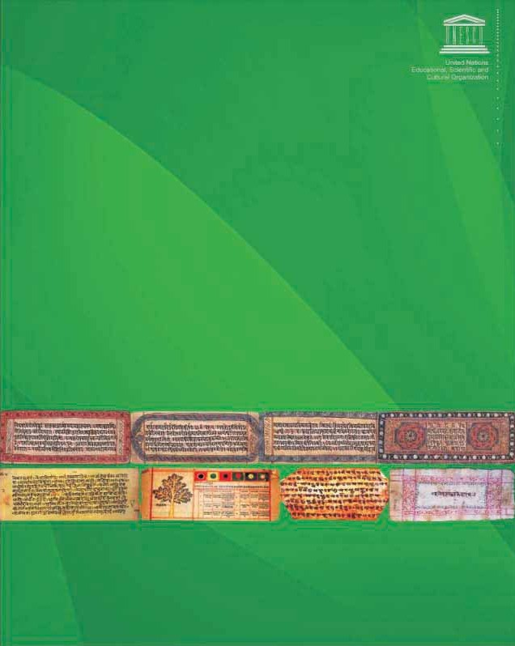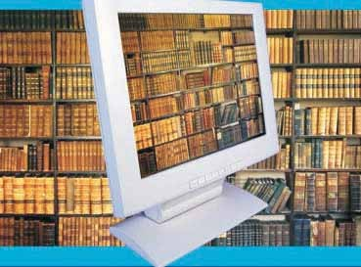

United Nations Educational, Scientific and Cultural Organization

**B 5/29, Safdarjung Enclave, New Delhi - 110029, INDIA Tel. : 91-11-26713000 Fax : 91-11-26713001/2**